BRB-ArrayTools

Version 3.0

User’s Manual

by

Dr. Richard Simon
Biometrics Research Branch
National Cancer Institute

and

Amy Lam
The EMMES Corporation

February 21, 2002

Table of Contents

Introduction 4
Purpose of this software 4
Overview of the software’s capabilities 4
A note about single-channel arrays 6
Installation 8
System Requirements 8
Installing the software components 8
Loading the add-in into Excel 9
Collating the data 10
Overview of the collating step 10
Input to the collating step 12
Input data types 12
Expression data 12
Gene identifiers 13
Experiment descriptors 13
User-defined genelists 14
Minimal required data elements 15
Collating data from raw files 17
Example 1 - Arrays are horizontally stacked in one file 17
Example 2 - Arrays are in separate files 21
Example 3 – Multi-chip sets 25
Collating Affymetrix data from MAS output files 28
Collating data from an NCI mAdb archive 31
Output of the collating step 32
Organization of the project folder 32
The collated project workbook 32
Filtering the data 35
Spot filters 35
Intensity filter 35
Spot flag filter 36
Spot size filter 36
Detection call filter 36
Transformations 36
Normalization 36
Median normalization 37
Housekeeping gene normalization 37
Lowess normalization 37
Truncation 37
Gene screening 38
Minimum fold-change filter 38
Log expression variation filter 38
Percent missing filter 39
Percent absent filter 39
Analyzing the data 40
Scatterplot tools 40
Scatterplot of single array versus array 40
Hierarchical cluster analysis tools 43
Cluster analysis of genes 46
Cluster analysis of samples 47
Multidimensional scaling of samples 49
Classification tools 51
Class comparison 52
Class Prediction 57
Prediction for new samples 59
Survival analysis 60
Specifying replicate arrays and paired samples 60
Programmable Plug-In Faciltiy 63
Hands-on practice using a sample dataset 65
Further help 72
Some useful tips 72
Excluding arrays from an analysis 72
Extracting genelists from HTML output 72
Creating user-defined genelists 72
Re-playing the three-dimensional rotating scatterplot 73
Stopping a computation after it has started running 75
Determining the order of the arrays in the collated data 75
Always save the collated project workbook when prompted! 76
Troubleshooting the installation 77
Testing the R COM 77
Updating the R Server and BRB-ArrayTools library references 78
Reporting bugs 80
References 81

Introduction

Purpose of this software

BRB-ArrayTools is an integrated software package for the analysis of DNA microarray data. It was developed by the Biometric Research Branch of the Division of Cancer Treatment & Diagnosis of the National Cancer Institute under the direction of Dr. Richard Simon. BRB-ArrayTools contains utilities for processing expression data from multiple arrays, visualization of data, multidimensional scaling, clustering of genes and samples, and classification and prediction of samples. BRB-ArrayTools features drill-down linkage to NCBI databases using clone, GenBank, or UniGene identifiers, and drill-down linkage to the NetAffx database using Probeset ids. BRB-ArrayTools can be used to analyze both single-channel and dual-channel arrays. The package is very portable and is not restricted to use with any particular array platform, scanners, image analysis software or database. The package is implemented as an Excel add-in so that it has an interface that is familiar to biologists. The computations are performed by sophisticated and powerful analytics external to Excel but invisible to the user. The software was developed by statisticians experienced in the analysis of microarray data and involved in research on improved analysis tools. BRB-ArrayTools serves as a tool for instructing users on effective and valid methods for the analysis of their data. The existing suite of tools will be updated as new methods of analyses are being developed.

Overview of the software’s capabilities

BRB-ArrayTools can be used for performing the following analysis tasks:

- Collating data: Importing your data to the program and aligning genes from different arrays. The software can load a maximum of 250 arrays consisting of up to 65,000 genes. However, other limitations may apply, which depend on the user's system resources. Both dual-channel and single-channel (such as Affymetrix) microarrays can be analyzed. Data should be in tab-delimited text format. Data which is in Excel workbook format can also be used, but will automatically be converted by BRB-ArrayTools into tab-delimited text format.

- Filtering and normalization: Filter individual spots (or probesets) based on channel intensities (either by excluding the spot or thresholding the intensity), and by spot flag and spot size values. Affymetrix data can also be filtered based on the Detection Call. For dual-channel chips, normalize arrays by median-centering the log-ratios in each array, by subtracting out a lowess-smoother based on the average of the red and green log-intensities, or by defining a list of housekeeping genes. For single-channel chips, normalize arrays by centering the log intensity of each array to the median log intensity of the first array, or by defining a list of housekeeping genes. Truncate outlying expression levels. Filter genes based on the percentage of expression values which are at least a specified fold-difference from the median expression over all the arrays, by the variance of log-expression values across arrays, by the percentage of missing values, and by the percentage of “Absent” detection calls over all the arrays (for Affymetrix data only).

- Scatterplot of array v. array: For dual-channel data, create clickable scatterplots using the log-red, log-green, average log-intensity of the red and green channels, or log-ratio, for any pair of arrays (or for the same array). For “M-A plots” (i.e., the plot of log-ratios versus the average red and green log-intensities), a trendline is also plotted. For single-channel data, create clickable scatterplots using the log-intensity for any pair of arrays. All genes or a defined subset of genes may be plotted. Hyperlinks to NCI feature reports, GenBank, NetAffx, and other genomic databases.

- Scatterplot of phenotype classes: Create clickable scatterplots of average log-expression within phenotype classes, for all genes or a defined subset of genes. Hyperlinks to NCI feature reports, GenBank, NetAffx, and other genomic databases.

- Hierarchical cluster analysis of genes: Create cluster dendrogram and color image plot of all genes. For each cluster, provides a hyperlinked list of genes, and a lineplot of median expression levels within the cluster versus arrays. The arrays may be clustered separately with regard to each gene cluster. Each gene cluster can be saved and used in later analyses. A color image plot of median expression levels for each gene cluster versus arrays is also provided. The cluster analysis may be based on all data or on a user-specified subset of genes and arrays.

- Hierarchical cluster analysis of samples: Produces cluster dendrogram, and statistically-based cluster-specific reproducibility measures for a given cut of the cluster dendrogram. The cluster analysis may be based on all data or on a user-specified subset of genes and arrays.

- Global test of clustering: Statistical significance tests for presence of any clustering among a set of arrays, using either the correlation or Euclidean distance metric. This analysis is given as an option under the multidimensional scaling tool.

- Multidimensional scaling of samples: Produces clickable 3-D rotating scatterplot where each point represents an array, and the distance between points is proportional to the dissimilarity of expression profiles represented by those points. If the user has PowerPoint installed, then a PowerPoint slide is also created which contains the clickable 3-D scatterplot. The PowerPoint slide can be ported to another computer, but must be run on a computer which also has BRB-ArrayTools v3.0 installed in order for the clickable 3-D scatterplot to work.

- Class comparison: Uses univariate parametric and non-parametric tests to find genes which are differentially expressed between two or more phenotype classes. Also computes a global permutation test of whether the number of apparently significant genes is greater than one would expect by chance. The output contains a listing of genes which were significant and hyperlinks to NCI feature reports, GenBank, NetAffx, and other genomic databases. The parametric tests are either t/F tests, or randomized variance t/F tests. The latter provide improved estimates of gene-specific variances without assuming that all genes have the same variance. The criteria for inclusion of a gene in the gene list is either a p-value less than a specified threshold value, or specified limits on the number of false discoveries or proportion of false discoveries. The latter are controlled by use of multivariate permutation tests.

- Class prediction: Constructs predictors for classifying arrays into phenotype classes based on expression levels. Five methods of prediction are used: compound covariate predictor, diagonal linear discriminant analysis, k-nearest neighbor (using k=1 and 3), nearest centroid, and support vector machines. The compound covariate predictor, diagonal linear discriminant analysis and support vector machines are only implemented for the case then the phenotype variable contains only two class labels, whereas the k-nearest neighbor and nearest centroid may be used even when the phenotype variable contains more than two class labels. Determines cross-validated misclassification rate and performs a permutation test to determine if the cross-validated misclassification rate is lower than would be expected by chance. The analysis may also be performed on paired samples. The output contains the result of the permutation test on the cross-validated misclassification rate, and a listing of genes which comprise the predictor, with parametric and permutation p-values for each gene, and hyperlinks to NCI feature reports, GenBank, NetAffx, or other genomic databases. Permits application of predictive models developed for one set of samples to expression profiles of a separate test set of samples.

A note about single-channel arrays

All of the tools within BRB-ArrayTools can be equally run on single-channel and dual-channel arrays. For Affymetrix data, it is suggested that the "signal" field produced in MAS 5.0 should be used as the intensity signal. If the "average difference" field is used as the intensity signal, then genes with negative "average difference" will be automatically thresholded to a value of 1 (log-transformed value of 0). For sake of convenience of exposition, we will assume dual-channel data throughout this document. We will refer to log-ratios, though a comparable analysis can be run on the log-intensities for single-channel data. We will also refer to "spots" but for Affymetrix arrays the analog of "spot" is the probe set used to detect the expression of a specified gene.

All analyses on log-intensities work exactly the same way as the analyses on log-ratios, but for two exceptions:

- Data normalization: The median-normalization of single-channel (e.g., Affymetrix) data is normalized such that the median log-intensity of each array is equal to the median log-intensity of the first array. Lowess (intensity-dependent) normalization is not available for single-channel data.

- Class prediction: To reduce the dominating effect that genes with overall high intensity might have, the single-channel log-intensities are median-centered on a gene-by-gene basis for all class prediction methods.

Installation

System Requirements

BRB-ArrayTools is Windows-compatible software, Windows 98/2000/NT/XP or later. It is designed to be used as an add-in to Excel 2000. BRB-ArrayTools is no longer supported for Excel 97.

It is recommended that the user have at least 256MB of RAM. It is possible to run BRB-ArrayTools with less than 256MB of RAM; however, some procedures may be very slow or may not be able to run at all, depending on the size of the dataset.

For producing high-resolution graphics, it is recommended that the user set the display color palette to True Color. To change the display color palette settings, click on the following sequence of items: Windows Start Button → Settings → Control Panel → Display → Settings.

Installing the software components

The BRB-ArrayTools software and associated files may be downloaded from the BRB website:

http://linus.nci.nih.gov/BRB-ArrayTools.html

If you have Excel open, please close Excel before installing BRB-ArrayTools.

There are three installation steps:

- If you do not already have the Java Runtime Environment v1.2.2 on your computer, then you should download and execute the jre-1_2_2_011-win.exe installation file. (If you already have a previous version of BRB-ArrayTools on your computer, then you do not need to complete this step because you should already have the JRE v1.2.2 on your computer.)

- If you do not already have the R 1.6.1 software on your computer, then you should download and execute the rw1061.exe installation file. (Previous versions of BRB-ArrayTools used R 1.2.0, so you will need to complete this step even if you already have a previous version of BRB-ArrayTools on your computer, unless you have already specifically upgraded your R to version 1.6.1.)

- Now you are ready to install BRB-ArrayTools. Download and execute the ArrayTools_v3_0beta.exe installation file. The BRB-ArrayTools installer will automatically install the R-COM into your R 1.6.1 installation directory. If you do not already have R 1.6.1 installed, then you need to go back to step 2 and install R 1.6.1 first. If you have a previous version of BRB-ArrayTools installed, then you should install the newer version into the same installation directory as the previous version, and the newer version will overwrite the previous version. (You should avoid installing BRB-ArrayTools in a different directory than the previous version, since this would require that you go through additional procedures when loading the add-in within Excel.)

Loading the add-in into Excel

To begin using BRB-ArrayTools, you must have BRB-ArrayTools loaded into Excel as an add-in. The BRB-ArrayTools installer now pre-loads BRB-ArrayTools into Excel, so users no longer have to load BRB-ArrayTools into Excel as a separate step as they did with previous versions of BRB-ArrayTools. Users may still load and unload BRB-ArrayTools in Excel manually by going to the Tools menu within Excel and clicking on Add-Ins.

If you close an Excel session with BRB-ArrayTools still loaded, then your next Excel session will automatically begin by re-loading BRB-ArrayTools. BRB-ArrayTools will not be unloaded from Excel unless you specifically unload it through the Add-Ins dialog.

Collating the data

Overview of the collating step

Collating is a process in which your data are read, sorted, and written to a standard Excel workbook format which is "understood" by BRB-ArrayTools. The user inputs three types of data (expression data, gene identifiers, and experiment descriptors) by entering parameters to describe the file format of each data type. BRB-ArrayTools then processes these data files and produces a collated project workbook which is a standard data format used by all the analysis tools included in the software package. Curated gene lists may also be used to define gene functions or pathways, and will be read in at the time of collating. The following page contains a diagram of the entire process.

A note about Excel workbooks
A single Excel file (with an .xls extension) is called a workbook, and a workbook may contain one or more spreadsheets called worksheets. A tab-delimited ASCII text file with an .xls extension, though not a true Excel object, is interpreted by Excel to be a workbook containing a single worksheet.

Expression data
(
one or more files)
Tab-delimited text files
(or Excel workbooks)
Gene identifiers
(
may be in a
separate file)
Experiment
descriptors
Collate
Collated project
Workbook
Excel workbook with
multiple worksheets
User defined
gene lists
One or more
text files
Run analyses
Filter
Tab-delimited text file
Tab-delimited text file
(or Excel workbook)
(or Excel workbook)

Input to the collating step

The input data files should be tab-delimited ASCII text files. Excel workbooks (where the input data is on the first worksheet if there are multiple worksheets within the workbook) may be used instead of tab-delimited text files. However, BRB-ArrayTools will automatically convert those Excel files into tab-delimited text format. If the user wishes to save a copy of the original Excel files, then the user should first save a copy of those original data files into another folder. The user must enter enough information describing the format of these input data files (such as the column designation of each data element) so that BRB-ArrayTools can find and process these data elements from the input files.

Input data types

Expression data

BRB-ArrayTools accepts three input file formats for the expression data: (1) arrays horizontally stacked in one file, (2) arrays in separate files, and (3) arrays from multi-chip sets. Multi-chip sets are sets of arrays in which the total number of clones or probesets are divided over several arrays. BRB-ArrayTools accepts multi-chip sets with up to 5 array types in the set, with each array in the set labeled as ‘A’, ‘B’, ‘C’, ‘D’, and ‘E’ for convenience. These three input formats will be described as examples in the “Collating data from raw files” section of this manual. The data format for multi-chip sets is similar to the data format for the horizontally stacked or separate files, except that for multi-chip sets, there is either one horizontally stacked file for each array type in the set, or one data folder for each array type in the set which contains a separate data file for each array which was performed of that array type. For multi-chip sets, the individual arrays are normalized separately, but the data for all arrays will be concatenated to form one large dataset. A “shortcut” interface is available for collating Affymetrix data outputted as text files from MAS 4.0 or 5.0, and for data archives downloaded from NCI’s mAdb system.

If the genes are listed in the same order and there is a one-to-one correspondence between the rows of each of the expression data files, then the data is said to be aligned. The horizontally stacked data format can only be used when the genes are already aligned, while the other two data formats may be used whether or not the genes are already aligned. When the input data is in separate files, BRB-ArrayTools will automatically align the data as it collates, and any gene which is multiply-spotted within any array will have its expression data geometrically averaged over the replicate spots within the array. Genes which are multiply-spotted over several arrays in a multi-chip set will only have replicates within the same array averaged, but replicates across different arrays will not be averaged.

The required expression data elements are either the red and green signal intensity columns or the log-ratio column (for dual-channel data), or a single signal intensity column (for single-channel data). If a background subtraction is desired for the dual-channel data, then the red and green background columns are also necessary. In addition, a spot flag or spot size column may optionally be entered, to allow spot filtering using these data elements. For Affymetrix data, the Detection Call (Absent, Marginal, or Present) may be used as the “spot flag” variable for the purpose of flag filtering.

Gene identifiers

Various identifiers can be associated with each spot, such as spot numbers, well numbers, clone names, clone identifiers, probe set identifiers, UniGene identifiers, GenBank accession numbers, etc. The gene identifiers may be located alongside the expression data in the same files, or may be contained in a separate file which is used as a look-up table for the genes on all the arrays. If the gene identifiers are contained in a separate file, then there must be corresponding columns within the expression data file(s) and the gene identifier file, containing gene ids which can be used for matching the gene identifiers with the expression data.

The column which is designated within BRB-ArrayTools as clone id should contain an organization-prefixed clone id (e.g., a prefix such as "IMAGE:", "ATCC:", "TIGR:" etc.). These clone ids can be used to link to clone reports in the NCBI database. Note that clone reports in the NCI mAdb database are only available for clones in the NCI Advanced Technology Center inventory or for other expression array sets which are tracked by BIMAS/CIT/NIH. All clone identifiers found within a clone id column which are numeric and have no prefix will be assumed to have a prefix of IMAGE by default.

Probe set ids are used to link to feature reports in the NCI mAdb database. Currently feature reports are available only for the Human Genome U133 A and B chips, and for the Mouse Genome U74 A-C chips. For Class Comparison, Class Prediction, and Survival Analysis output, probe set ids are also used for batch query links to NetAffx.

UniGene cluster ids and gene symbols are used to search for the UniGene annotation mirrored in the NCBI database. GenBank accession numbers are used to search for the GenBank annotation which is also mirrored in the NCBI database.

A minimum of one gene identifier is required for use in collating the dataset. However, the user may wish to enter any or all of the above gene identifiers, if they are available, to enhance the usability of the output from the analyses.

Experiment descriptors

A file containing experiment descriptors must be prepared by the user and input during collation. Each row in the experiment descriptor file represents an array in the dataset (except for the first row which is a header row), and each column represents a descriptor variable whose entries are used to describe each of the arrays. The experiment descriptor file should contain exactly the same arrays as those to be collated (i.e., it should not contain any extra rows representing arrays which are not represented in the dataset to be collated).

The first column of the experiment descriptor file should contain the names of the arrays. If the expression data is in a separate file for each array, these names should be the filenames (without extensions). For horizontally stacked data, the order of the arrays in the experiment descriptor file is assumed to correspond to the order of the arrays in the gene expression data file.

For multi-chip sets with separate data files for each array, the array names in the first column of the experiment descriptor file should contain the filenames (without extensions) of the arrays which are in the data folder for array type ‘A’.

Each succeeding column in the experiment descriptor file contains a descriptor variable which may be used for labeling purposes, for identifying reverse fluor arrays, for classification analyses, for identifying replicate arrays, for matching between paired arrays, or for specifying the plotting order of the arrays when clustering genes. The user can create as many columns of the experiment descriptor file as he/she finds useful for classifying the arrayed samples. There should be no empty columns between the experiment descriptor columns.

User-defined genelists

BRB-ArrayTools allows the user to associate genes with defined functions or pathways through the use of user-defined genelists. Unlike the other input data files mentioned above which collectively describe the expression, genes, and samples of a specific project, the user-defined genelists are stored in the ArrayTools installation directory, and are used as a general database for all projects which are analyzed within BRB-ArrayTools.

In the ArrayTools installation directory, there is a Genelists subdirectory, which contains the subdirectories Cgap and User. The Cgap directory contains curated gene lists which have been downloaded from the Cancer Genome Anatomy Project website (http://cgap.nci.nih.gov/Genes/CuratedGeneLists). These HTML files will be updated with each new release of BRB-ArrayTools, and may be manually updated in the interim by the user by replacing or adding to the existing files with new files downloaded from the CGAP website.

The User directory contains genelists which may be created by the user. Unlike the HTML formatted files contained in the Cgap directory, the files contained in the User directory are simply ASCII text files containing lists of genes. The name of the file denotes the function or pathway which is defined by the genes listed in the file. The first row of the file specifies the type of gene identifier used within the file, and must exactly match one of the following pre-defined labels

Unique id
Description
Clone
Probe set
GB acc
UG cluster
Gene symbol

or must exactly match one of the write-in gene identifier names specified in the column format section of the gene identifiers page of the collating data dialog box. Each succeeding row of the file should contain the gene identifier of a specific gene or clone to be included in the list.

The User directory currently contains some examples of genelists which will be used with the BreastSamples dataset which is provided with this package. These example genelists are used with the example dataset, and may be deleted at any time by the user.

Some procedures will automatically create new user genelists. The following procedures can be used to create new genelists: the hierarchical clustering of genes, the class comparison tool, and the class prediction tool. The name of the genelist which is produced by the class comparison or class prediction tool is specified by the user before running the analysis. If there is already an existing genelist with the same name, then that genelist will be overwritten.

During the collating step, genes in the user's dataset will automatically be matched against CGAP and user-defined genelists which are currently stored within the Genelists folder. If any of the genes in the user's dataset match any of the genelists, then the name of the genelist will appear in a column of the gene identifiers page in the collated project workbook. If the user adds a new genelist after the data has already been collated, then the gene annotations in the gene identifiers page can be updated by clicking on the ArrayTools → Utilities → Annotate data using genelists menu item.

Minimal required data elements

Although there are many optional data elements which may be input into the collating step, the minimal required data elements for all input formats are as follows:

- the expression data (either the red and green signals or the log-ratio for dual-channel data, or the single signal intensity for single-channel data),
- at least one gene identifier (may be located alongside the expression data or in a separate gene identifier file), and
- at least one experiment descriptor column (the array id) in the experiment descriptor file.

Collating data from raw files

Example 1 - Arrays are horizontally stacked in one file

Format of the raw data files

In this file format, the expression data from each array is represented by a block of columns in the data file, and the array data blocks are horizontally stacked in one file. There may be other columns, such as gene identifiers, which precede the array data blocks. However, there should be no other miscellaneous data columns following the last array data block. If there are any other data columns following the last array data block, then the user should either delete those last columns or move them to the beginning of the file so that they precede the first array data block.

The file may be a tab-delimited ASCII text file, or an Excel spreadsheet (a single worksheet within an Excel workbook). If the file is an Excel spreadsheet, then BRB-ArrayTools will automatically convert it to text format. The following figure shows an example of a horizontally stacked expression data file with four columns in each data block:
Array data block #1

Array data block #2

Array data block #3

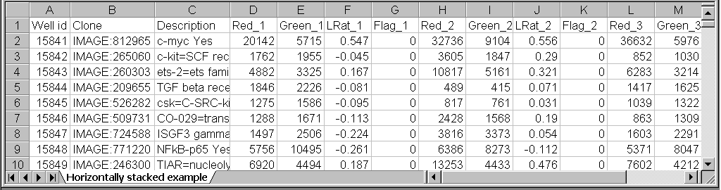

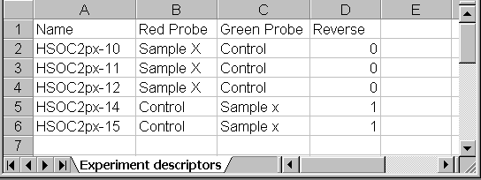
The figure to the right shows the experiment descriptor file. The experiment descriptor file describes the samples used in the dataset. This particular dataset is a replication study. Each row of the experiment descriptor file describes the sample on one array. The order of the arrays listed in the experiment descriptor file are assumed to correspond to the order of the array data blocks in the expression data file. Thus, array data block #1 will be matched with HSOC2px-10 in row 2 of the experiment descriptor file, array data block #2 will be matched with HSOC2px-11 in row 3 of the experiment descriptor file, etc. The Reverse descriptor in column D indicates the arrays on which the fluors were reversed.

Collating parameters

There are two ways in which the data may be specified in the collating dialog form. One way is to enter the red and green signal columns, and let BRB-ArrayTools compute the log-ratio. Another way is to enter the log-ratio column directly. The user is not permitted to enter both the log-ratio and the dual-channel signals, since the log-ratios can be computed once the dual-channel signals are entered. It is preferred that the dual-channel signals be entered (if they are available) rather than the log-ratio, since BRB-ArrayTools can use the signal intensities for filtering, lowess (intensity-based) normalization, and creating diagnostic scatterplots. If the log-ratios are entered directly, then these functionalities are not available to the user.

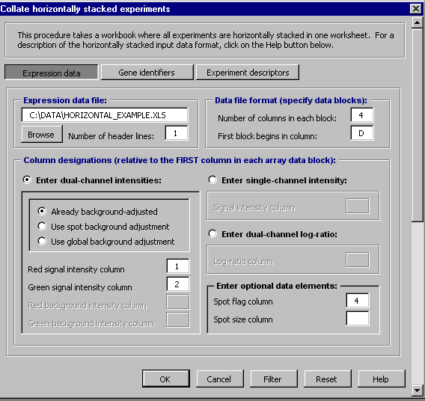
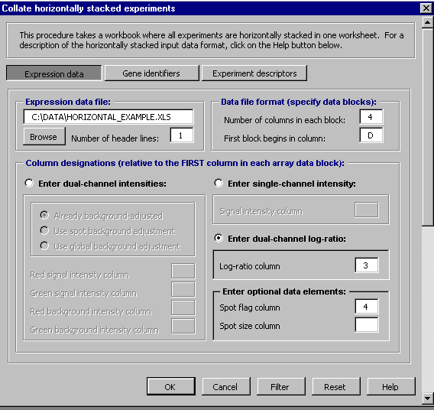
The first figure on the right shows the collating parameters which would be entered on the Expression data page of the collating dialog box to describe the horizontally stacked data file shown above, if the signal intensities were to be entered rather than the log-ratio. The user should browse for or type in the name and path of the file which contains the expression data. Note that the column designations of the red, green, and spot flag variables are relative to the first column of the array data block. In other words, a designation of “4” for the spot flag column means that the spot flag is in the fourth column of each array data block. Any extra columns within the array data blocks which are not specifically designated in the Data variables section of the collating dialog box, such as the third column (the log-ratios), will be ignored during the collating step. Since BRB-ArrayTools automatically calculates the log-ratio from the red and green signals, it is not necessary to enter the log-ratios as input. The second figure on the right shows the collating parameters which would be entered on the Expression data page of the collating dialog box to describe the horizontally stacked data file shown above, if the log-ratios were to be entered directly instead of the signal intensities.

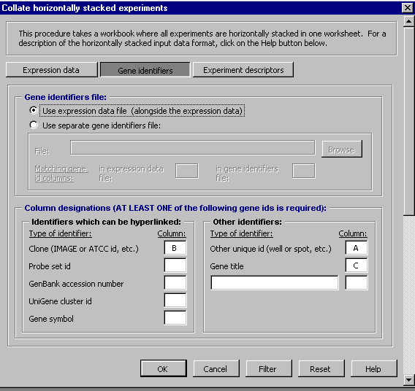
The figure on the right shows the collating parameters which would be entered on the Gene identifiers page of the collating dialog box. In this case, the gene identifiers are found in the same rows alongside the expression data, not in a separate file. The gene identifiers are specified by their column designation under the Column format section, which are given relative to the file specified in the File section.

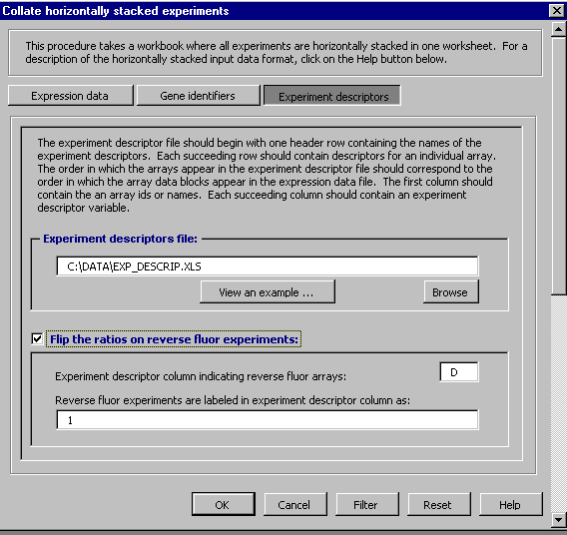
The figure on the right shows the collating parameters which would be entered on the Experiment descriptors page of the collating dialog box. The user should browse for or type in the file and path name of the experiment descriptor file. In this case, any array with a label of 1 in column D of the experiment descriptor file would have its intensity ratios “flipped” so that the log-ratios in that array are “reversed” to have the opposite sign.

The Filter dialog box, which allows the user to change the default filtering parameters, will be reviewed in a separate section of this manual. After all the collating and filtering parameters have been entered, the user will be prompted for the name of the project folder and the name of the collated project workbook to be created.

Example 2 - Arrays are in separate files

Format of the raw data files

In this file format, the expression data from each array is stored in a separate file. All files must have the same column format, though the genes contained in the rows of the separate files may differ. Each file may be a tab-delimited ASCII text file, or an Excel spreadsheet (a single worksheet within an Excel workbook). If the files are a Excel spreadsheets, then BRB-ArrayTools will automatically convert them to text format. The BreastSamples dataset enclosed with this software package is an example of this data format. This dataset was obtained from published data by Ross, et al.

To view the BreastSamples dataset, unpack the BreastSamples.zip file using WinZip or other utility. When you unpack the dataset, you should get a folder called BreastSamples, containing a gene identifier file called GeneIds.xls, an experiment descriptor file called ExpDesc.xls, and a subfolder called ExpressionData. Inside the ExpressionData subfolder, there are thirteen expression data files. The expression data files in this dataset are already aligned.
The following figure shows the format of each of the expression data files:
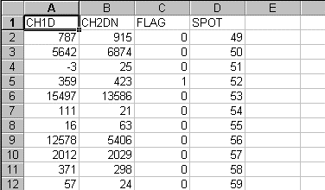

The following figure shows the format of the gene identifiers file:

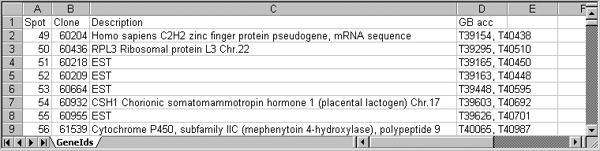

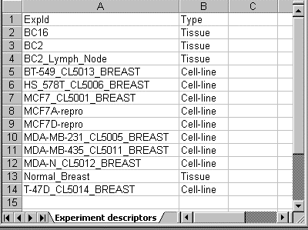
The following figure shows the format of the experiment descriptors file:

Collating parameters

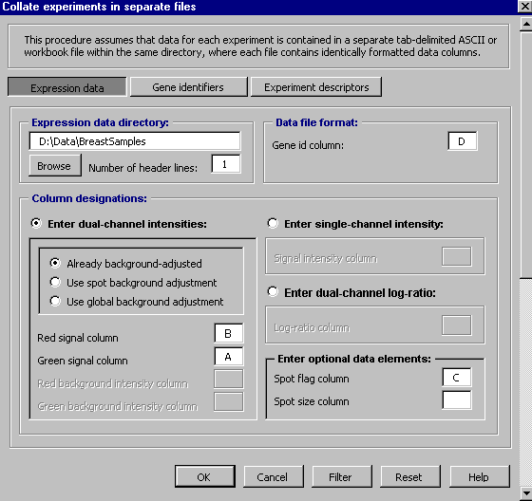
The following three figures show the collating parameters which would be entered on the Expression data page, Gene identifiers page, and Experiment descriptors page of the collating dialog box, for collating the BreastSamples data using SPOT as the unique gene identifier which links the expression data with the gene identifiers.

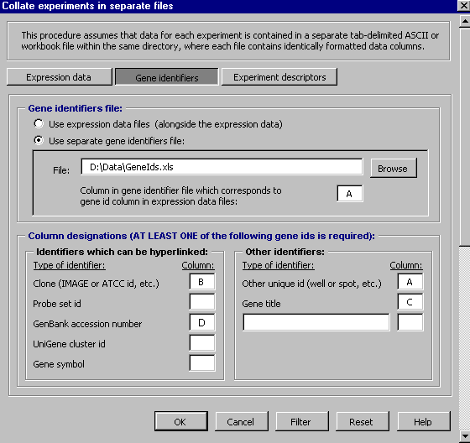

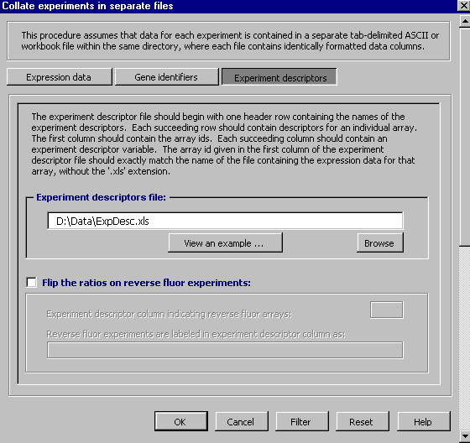

The Filter dialog box, which allows the user to change the default filtering parameters, will be reviewed in a separate section of this manual. After all the collating and filtering parameters have been entered, the user will be prompted for the name of the project folder and the name of the collated project workbook to be created.

Example 3 – Multi-chip sets

Format of the raw data files

In this file format, it is assumed that the user has up to five array types in the multi-chip set, which for convenience are designated within BRB-ArrayTools as type ‘A’, ‘B’, ‘C’, ‘D’, and ‘E’. For example, the Affymetrix U133 is a multi-chip set, with the total set of probesets divided between the U133A and U133B chips. The user does not need to have performed experiments using all of the array types in a multi-chip set, but it is expected that for the array types which were actually used from the set, the same samples should have been used for each array type. For example, if the user chose to use only two chip types from a five-chip set, then for each sample used on array type ‘A’, the same sample should also have been used on array type ‘B’.

The data for each of the array types, can in turn be in the horizontally stacked or separate files format, as described in Examples 1 and 2. If the data for each array type is in a horizontally stacked format, then all the horizontally stacked files should have the same format, with the same number of data columns in each file. The following is an example of the data columns which might be found for a multi-chip set consisting of two array types, with three samples performed on each array type:

DataFileA.txt

GeneId | Exp1_Signal | Exp1_Flag | Exp2_Signal | Exp2_Flag | Exp3_Signal | Exp3_Flag
Gene1
Gene2
Gene3

DataFileB.txt

GeneId | Exp1_Signal | Exp1_Flag | Exp2_Signal | Exp2_Flag | Exp3_Signal | Exp3_Flag
Gene1
Gene2
Gene3

In the above example, the array data blocks consist of 2 columns each, with Signal being in column 1 of each array data block, and Flag being in column 2 of each array data block. The first data block begins in column 2.

If the same dataset were formatted in the separate files format, then the user would have two folders, with each folder containing a data file for each of the three experiments Exp1, Exp2, and Exp3, as follows:

In data folder ‘A’:

Exp1a.txt

GeneId | Signal | Flag
Gene1
Gene2
Gene3

Exp2a.txt

GeneId | Signal | Flag
Gene1
Gene2
Gene3

Exp3a.txt

GeneId | Signal | Flag
Gene1
Gene2
Gene3

In data folder ‘B’:

Exp1b.txt

GeneId | Signal | Flag
Gene1
Gene2
Gene3

Exp2b.txt

GeneId | Signal | Flag
Gene1
Gene2
Gene3

Exp3b.txt

GeneId | Signal | Flag
Gene1
Gene2
Gene3
The filenames in data folder ‘A’ and data folder ‘B’ are allowed to differ by a one-character suffix, but need not differ at all. However, the array labels in the first column of the Experiment Descriptor file should always match the filenames in data folder ‘A’ (without the file extensions), not the filenames in the other data folders.

For example, the following sets of filenames are all acceptable:

Data Folder ‘A’: Exp1.txt, Exp2.txt, Exp3.txt
Data Folder ‘B’: Exp1.txt, Exp2.txt, Exp3.txt

(The first column of the Experiment Descriptor file should contain the array labels Exp1, Exp2, and Exp3 in this case.)

or

Data Folder ‘A’: Sample1.txt, Sample2.txt, Sample3.txt
Data Folder ‘B’: Sample1b.txt, Sample2b.txt, Sample3b.txt

(The first column of the Experiment Descriptor file should contain the array labels Sample1, Sample2, and Sample3 in this case.)

However, the following set of filenames are not acceptable, because BRB-ArrayTools would not know how to match up the files in data folder ‘A’ with the files in data folder ‘B’

Data Folder ‘A’: Sample1.txt, Sample2.txt, Sample3.txt
Data Folder ‘B’: Exp1.txt, Exp2.txt, Exp3.txt

Collating Affymetrix data from MAS output files

BRB-ArrayTools has a dialog especially designed for easy importing of Affymetrix data. To access this tool, go to the ArrayTools → Collate data → Affymetrix GeneChips menu item.

If the user has Affymetrix data, then the CHP files should be exported from MAS 4.0 or 5.0 as tab-delimited text files in either the “horizontally stacked” or “separate files” input data formats as previously described.

If data is exported in the horizontally stacked input data format, then a Pivot Table should be created for each chip type, containing the absolute analysis data from all experiments which were performed of that chip type, and each pivot table should be exported as a tab-delimited text file.

If the data is exported in the “separate files” format, then the Metrics Table data from each CHP file should be exported as a separate tab-delimited text file, and the files should be named and organized into folders as described in “Example 3 – Multi-chip sets” above.

The files may contain miscellaneous rows before the column header row, but all files must have the exact same format (and same number of miscellaneous rows before the column header row). BRB-ArrayTools will be able to automatically read and parse the tab-delimited text files if the text files have a header row in any of the following formats.

In all of the following formats, the “Probe Set Name”, “Signal” and “Detection” are the only required columns from MAS 5.0 data, and the “Probe Set Name”, “Avg Diff” and “Abs_Call” are the only required columns from MAS 4.0 data. All other columns are optional.

BRB-Arraytools can automatically recognize the data format of files that have been exported directly from MAS 4.0 and MAS 5.0. However, users who choose to edit the data columns and column headers of their files should follow the format described below, in order for BRB-ArrayTools to automatically recognize the data format. If the column header row is not in any of the following formats, then BRB-ArrayTools will not be able to parse the files automatically. In that case, the user will need to use either the ‘horizontally stacked’ or ‘separate files’ collating dialogs (for a single array type) or the “multi-chip sets” collating dialog (for multi-array sets), in order to collate the data.

For expression data in a “horizontally stacked” file (using one horizontally stacked file for each chip type):

1. For expression data outputted from a Pivot Table in MAS 5.0:

Probe Set Name Description Exp1_ Signal Exp1_Detection Exp2_Signal Exp2_Detection
1053_at Human replication 234 P 456 P
1773_at Human farnesyl- 123 P 39 P

2. For expression data outputted from a Pivot Table in MAS 4.0:

Probe Set Name Description Exp1_Avg Diff Exp1_Abs_Call Exp2_Avg Diff Exp2_Abs_Call
1053_at Human replication 234 P 456 P
1773_at Human farnesyl- 123 P 39 P

For the above two formats, the prefixes Exp1 and Exp2 will be used as experiment names in the collated project workbook. You may use any other experiment names, but do not use the following special characters “\ / : * ? “ < > | .” which have special meanings in Windows. The “Probe Set Name” column label may also be given as simply “Probe Set”. The detection (Abs_call) column should be right next to the signal (Avg Diff) column for each experiment.

For expression data in a “Separate Files” format:

1. For expression data outputted from a Metric Table in MAS 5.0:

Probe Set Name Description Signal Detection
1053_at Human replication 234 P
1773_at Human farnesyl- 123 P

2. For expression data outputted from a Metric Table in MAS 4.0:

Probe Set Name Description Avg Diff Abs_Call
1053_at Human replication 234 P
1773_at Human farnesyl- 123 P

3. In addition to the above mentioned file formats, the following file format from the NCBI portal will also be recognized:

ID_REF VALUE ABS_CALL
AFFX-MurIL2_at -896 A
AFFX-MurIL10_at 682 A

4. In addition to the above mentioned file formats, the following file format from mAdb will also be recognized:

AffyId Signal Detection Call
A28102_at 7.002252579 A
AB000114_at 4.121015549 A

Each file should contain data from one chip or array. The files from a different chip type or array type should be placed in a separate folder. The names of the separate files will be used as experiment names in the collated project workbook.

Gene annotations file format:

If you have probe set annotation columns other than the Description column, please place them in a separate tab-delimited gene annotation file and use the following column header labels. For multi-chip sets, please place all your probe set annotation information in just one file.

Probe Set ID or Probe Set Name - the name of the probe set.

Title or Description - the description or title of the probe set.

Unigene - the Unigene Id.

Gene Symbol - the gene symbol.

GenBank or SeqDerivedFrom - the GeneBank Id or source of the sequence.

Map Location or Chromosomal Location - the location of the gene in the chromosomal map.

Collating data from an NCI mAdb archive

BRB-ArrayTools has an interface which allows the National Cancer Institute Advanced Technology Center users to easily collate their data which has been downloaded from the "mAdb" website as a zipped archive. With this interface, the user only needs to browse for the folder which contains their unpacked archive, and specify whether or not the genes are aligned and whether or not the data contains reverse fluor experiments. If the data contains reverse fluor experiments, then the user should first edit the array_descriptions file by entering a reverse fluor indicator in column "G", in which reversed arrays are denoted by the label “Yes”.

Currently, this collating interface is only for dual-channel cDNA data, not for Affymetrix data. If the user has a mAdb archive which contains Affymetrix data, then the user will need to use the “horizontally stacked”, “separate files”, “multi-chip”, or “Affymetrix” collating dialogs.

The zipped archive should be unpacked before collating. When unpacking the archive, please check to make sure the directory structure of the archive has been preserved.

When the data for each array is in a separate file, there should be two files

array_descriptions_xxx_xxxxxx.xls
gene_identifiers_xxx_xxxxxx.xls

and a folder

array_data_xxx_xxxxxx

which are unpacked into the same directory. The array_data_xxx_xxxxxx folder contains all the expression data files, where each file contains the expression data for a single array.

Output of the collating step

Organization of the project folder

During the collating step, BRB-ArrayTools will create a project folder either within or alongside the folder which contained the user's original raw data files. This project folder will contain the collated project workbook, as well as supporting files needed by the collated project workbook. Some BRB-ArrayTools analyses may also produce various output files, which will be written to an Output folder within this project folder. For example, all the plots which appear onscreen in the Cluster viewer page during cluster analysis are also automatically saved into the Output folder, and may be subsequently edited by the user for publication.

The collated project workbook

The collating procedure produces a collated project workbook. This is an Excel workbook containing three worksheets labeled Experiment descriptors, Gene identifiers, and either filtered log-ratio (for dual-channel data) or filtered log intensity (for single-channel data). All other data variables, such as the red and green background-adjusted signals and raw log-ratios (for dual-channel data), the raw log-intensities (for single-channel data), the spot flag (or Detection Call, for Affymetrix data), and the spot size, will be written to separate workbooks within the project folder.

The rows in the gene identifiers worksheet correspond to the rows in the filtered log-ratio (or filtered log intensity) worksheet. The last column of the gene identifiers and filtered log-ratio (or filtered log intensity) worksheets contains a filtering variable will be adjusted each time the user adjusts the filtering levels. To change the filtering criteria for any given analysis, the user should not manually edit the filtering column in these worksheets, but should set the filtering criteria by clicking on the Filter button at the bottom of the dialog box for each analysis.

The experiment descriptors worksheet of the collated project workbook contains an editable copy of the experiment descriptors file which was collated with the data. This copy can be edited by the user to add descriptors to be used in later analyses, as in the example below:

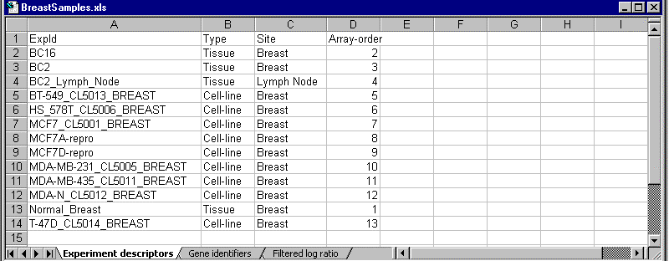
The Array-order descriptor variable, for example, might be used to specify the order of arrays to use when plotting lineplots of gene cluster expression.

The gene identifiers worksheet of the collated project workbook contains the gene identifiers whose columns had been specified in the column format section under the gene identifiers page of the collating dialog box.

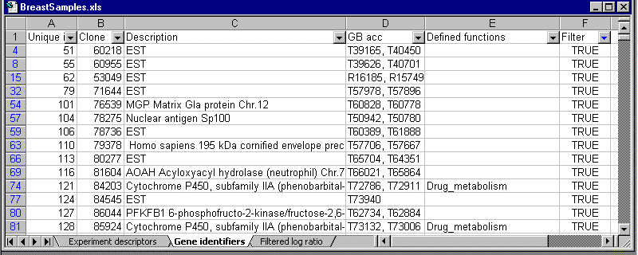
A column labeled Defined genelists will be added to the gene identifiers, indicating if the genes matched any of those listed in the user defined gene lists.

The click-arrows in each cell of the header row may be used to search for specific values of each variable. Column-widths may be adjusted by hovering the cursor between the columns in the lettered column header bar and dragging.

The filtered log ratio (or filtered log intensity) worksheet contains the log-ratios (or log intensities) after the specified filtering levels have been applied. These are the data values which will be used for all analyses except the scatterplot of array v. array, where the log of the channel intensities can also be plotted for dual-channel data. The first column of the worksheet contains the primary gene id, which matches the gene id listed in the first column of the gene identifiers worksheet. Each succeeding column contains the log-ratios obtained from a single array. The highlighted yellow columns at the end of the dataset are used internally by BRB-ArrayTools for gene-filtering purposes. The user should not edit this worksheet in any way. BRB-ArrayTools will automatically re-filter this worksheet, if necessary, before running each analysis.
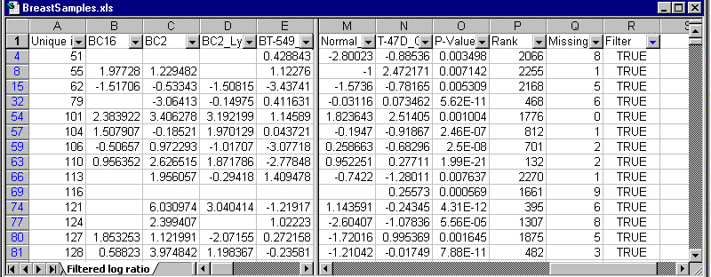

Filtering the data

The filtering criteria are specified during the data collating step, and may be changed prior to each analysis. The dialog box for each analysis has a Filter button on the bottom, which can be used to specify or change the filtering criteria for all subsequent analyses.

Although the filtering criteria may be changed for each analysis, it may be important to check the filtering criteria before collating the data if the data contains replicate spots for some genes in the array. This is because the spot filtering is applied before averaging the replicate spots, and replicate spots are not re-averaged after the collating step has been completed, even if the user changes the filtering criteria.

The Filtered log ratio (or Filtered log intensity) worksheet of the collated project workbook will reflect the filtering actions which have been selected. With the exception of replicated spots which are filtered before averaging, the supporting files which are located in the project folder will not reflect the filtering actions which have been selected.

The order of operations for filtering the data is that spot filters are applied first, then data normalization, then truncation of extreme values, then gene screening.

Spot filters

Spot filtering refers to filters on spots in individual arrays. Spot filtering is used for quality-control purposes, to filter out "bad" spots. Unlike gene screening, spot filtering does not filter out the entire gene (row), but replaces the existing value of a spot within any given array with a missing value.

Intensity filter

For dual-channel data, a spot may either be filtered out (excluded) from the analysis, or thresholded (with one signal set equal to the specified minimum) in the analysis. Using the filtering option, a spot on any array which has a red signal less than the specified minimum and/or a green signal less than the specified minimum will have its log-ratio value filtered out on the filtered log ratio worksheet. Using the thresholding option, a spot on any array which has BOTH signals less than the specified minimum will be filtered out, but a spot which has only ONE signal less than the specified minimum will have the below-minimum value set equal to the specified minimum, in computing the log-ratio value which is shown in the filtered log ratio worksheet. The intensity filter is applied to the background-adjusted red and green signals.

For single-channel data, a spot on any array which has a signal intensity less than the specified minimum may either be filtered out or thresholded on the filtered log intensity worksheet.

Spot flag filter

The spot flag filter can contain both numeric and character values. The user may specify a numeric range outside of which a numeric flag is considered to be “excluded”, and/or specify a list of flag values denoting the “excluded” values. When the flag filter is on, a spot on any array which has an “excluded” flag value will be filtered out on the filtered log ratio (or filtered log intensity) worksheet. The flag field is optional.

For Affymetrix users, a Detection Call column can be designated as the spot flag column at the time of collating, allowing users to filter out expression values which have an Absent call. Additionally, the spot flag column (or Detection Call column, for Affymetrix users) is also used by the Percent Absent Filter, to filter out spots (or probesets) with a large percentage of expression values which have a spot flag (or Detection Call) value of “A”.

Spot size filter

The spot size field is optional, but when the spot size filter is on and the spot field is present, then a spot on any array which has a spot size less than the minimum value will be filtered out on the filtered log ratio (or filtered log intensity) worksheet. For Affymetrix data, the number of pairs used to compute the signal can be used as a surrogate for the spot size measurement.

Detection call filter

For data collated using the Affymetrix GeneChips collating interface, the Detection call filter is a special case of the spot flag filter mentioned above, allowing users to filter out expression values based on the Detection call. The Detection data column is also used by the Percent Absent Filter to filter out probesets with a large percentage of Detection Calls which have a value of “A”.

Transformations

A logarithmic (base 2) transformation is applied to the signal intensities (for single-channel data) or intensity-ratios (for dual-channel data) before they are normalized and truncated. The effect of the data normalization and truncation will be reflected in the Filtered log ratio (or Filtered log intensity) worksheet of the collated project workbook.

Normalization

There are currently three normalization options: median normalization, housekeeping gene normalization, and lowess normalization. The median normalization and housekeeping gene normalization options are available for both single-channel and dual-channel data, but the lowess normalization option is available only for dual-channel data.

Median normalization

For single-channel data, the log-intensities are normalized by subtracting a constant from each array so that the median over each array is the same as the median over the first array. For dual-channel data, each array is normalized separately by subtracting the median log-ratio from all the log-ratios on the array. This is equivalent to multiplying all of the intensities in one channel of an array by a normalization factor.

Housekeeping gene normalization

The user may specify a housekeeping genelist which will be used for normalization. For single-channel data, the normalization factor for each array is computed as the median log-intensity over the housekeeping genes on the first array minus the median log-intensity over the housekeeping genes on the array being normalized. This normalization factor is added to all the log-intensities over the array. For dual-channel data, the median log-ratio over the housekeeping genes is subtracted from all the log-ratios on each array.

Lowess normalization

For dual-channel data, a lowess (or intensity-dependent) normalization option is also available. For dual-channel data, median normalization is equivalent to multiplying all of the intensities in one channel of an array by a normalization factor. In some cases it can be advantageous to have a different normalization factor for different intensity levels; i.e. the dye bias may be different for low intensity spots relative to high intensity spots. In the lowess normalization, a non-linear lowess smoother function is fit to the graph of un-normalized log-ratio on the y-axis versus average log intensity (i.e. [log(Red)+log(Green)]/2 ) on the x-axis. This is the so-called M-A plot. The lowess smoother is based on a concatenation of linear regressions for points in overlapping intervals on the x-axis of the M-A plot. This lowess smoother is subtracted from the un-normalized log-ratios for the array in order to obtain the normalized log-ratios. The lowess normalization is much more computationally intensive than the median centering normalization and may require up to 10 seconds per array on some computers using data with 35,000 genes. You may wish to first normalize your data using the default method and then examine M-A scatterplots to determine whether intensity dependent normalization is needed. If most of the points of the M-A plot are distributed equally above and below the 0 value of the y-axis, without a trend over x-values, then intensity based normalization is not needed.

Truncation

This option allows the user to specify a maximum intensity (for single-channel data) or intensity ratio (for dual-channel data) to be used for analysis. Any values greater than the specified threshold will be truncated to the threshold. For truncation of intensity ratios, both the intensity ratios and inverse intensity ratios will be truncated (e.g., an intensity ratio threshold of 64 means that all intensity ratios will be truncated to lie between 1/64 and 64).

Gene screening

Gene screening, unlike spot filtering, is not applied on an array-by-array basis for each gene. Instead, it uses a criterion based on all arrays for a given gene, to determine if that gene should be screened out or not. Its purpose is not to filter out "bad" spots, but rather to screen out genes which are not likely to be informative. The last column (labeled Filter) on the Gene identifiers and Filtered log ratio (or Filtered log intensity) worksheets are internally used by BRB-ArrayTools to select the genes which pass the screening.

Minimum fold-change filter

Genes which have low variation may be filtered out using the minimum fold-change filter. Here the criterion for filtering out a gene is based upon the percentage of expression values for that gene which have at least a minimum fold-change from the median expression value for that gene. The user may specify the minimum fold-change which is required. If less than a specified percentage of expression values meet the minimum fold-change requirement, then the gene is filtered out.

Log expression variation filter

Here the criterion for filtering out a gene is based upon the variation of its log expression values across all arrays after normalization. Filtering low variance genes is not really necessary except for clustering genes, where the computer memory requirements increase rapidly with the number of genes clustered. Several filtering options are available.

One option is to filter the gene if the proportion of the arrays in which the expression of the gene differs less than two-fold from the median expression of that gene does not exceed a specified threshold. A fold-difference criteria other than two-fold may also be specified by the user. The median expression of each gene is computed over all of the arrays.

Alternatively, the filtering can be based on the variance for the gene across the arrays. One can exclude the x% of the genes with the smallest variances, where the percentile x is specified by the user. Or a statistical significance criterion based on the variance can be used. If the significance criterion is chosen, then the variance of the log-ratios for each gene is compared to the median of all the variances. Those genes not significantly more variable than the median gene are filtered out. The significance level threshold may be specified by the user. Specifically, the quantity (n-1) Var_{i} / Var_{med} is computed for each gene i. Var_{i} is the variance of the log intensity for gene i across the entire set of n arrays and Var_{med} is the median of these gene-specific variances. This quantity is compared to a percentile of the chi-square distribution with n-1 degrees of freedom. This is an approximate test of the hypothesis that gene i has the same variance as the median variance.

Percent missing filter

Here the criterion for filtering out a gene is based upon the percentage of expression values which are not missing and not filtered out by any of the previous spot filters.

Percent absent filter

Here the criterion for filtering out a gene is based upon the percentage of Absent calls in the Spot Flag or Detection variable. This gene filter may be applied independently of the Spot Flag Filter or Detection Call Filter described in the “Spot Filters” section above, though it uses the same Spot Flag or Detection Call variable. For instance, a user may choose to turn off the Detection Call Filter in order to preserve all “Absent” expression values as they are, but turn on the Percent Absent Filter in order to exclude probesets which are considered unreliable or uninteresting because too many of the expression values were “Absent”. In this case, probesets which did not get excluded by the Percent Absent Filter still maintain their expression values even for those values which were “Absent”.

Analyzing the data

Scatterplot tools

Scatterplot of single array versus array

It is frequently of interest to plot the log-ratios of one array versus the log-ratios of another array. Generally, most of the plotted points, which represent genes with nonmissing values in both arrays, will line up along a 45-degree diagonal line. All genes which pass the filtering criteria will be used in the scatterplot, unless a genelist has been selected. Genes which are differentially expressed between the two arrays will fall outside of a pair of outlier lines. These outlier lines can be specified by the user to indicate genes whose expression ratios in the two arrays are larger than a given fold-difference.

The user may click on individual points in order to identify its associated gene and to hyperlink to annotated clone reports within NCBI database. Or, all the genes outside of the outlier lines can be simultaneously selected by clicking on a button.

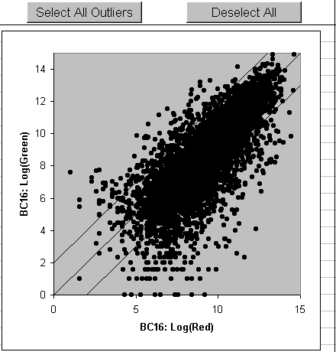
For dual-channel arrays, it may also be of interest to plot the log-intensity of one channel versus the log-intensity of the other channel, or to plot the reference sample in one array versus the reference sample in another array (to check reproducibility). Such plots might reveal any of the following descriptive features: whether or not one channel is uniformly higher than the other, whether the two channels are linearly related (they should be if most genes are not differentially expressed between the two samples), and whether or not there are points which are “clumped” away from the mass of points. A plot of log(Red) versus log(Green) within the same array will often show a “fanning” out effect at the lower end, showing that low-intensity spots are generally less reproducible than the higher-intensity spots. These plots can sometimes be used to help determine appropriate thresholds for the intensity filter.

For dual-channel arrays it may be easier to detect non-linearities that represent inadequate normalization by examining the so-called M-A plot, rather than the plot of log(Red) versus log(Green). The M-A plot is a graph of the normalized log-ratio on the y-axis versus average log intensity (i.e. [log(Red)+log(Green)]/2 ) on the x-axis. Most of the points of the M-A plot should be distributed equally above and below the 0 value on the y-axis, without a trend over x-values. If there is a trend, then intensity based normalization may be needed.
Scatterplot of phenotype averages

To compare the arrays in one phenotype class versus the arrays in another phenotype class, BRB-ArrayTools provides a tool which plots the average log-ratio within one class on the x-axis versus the average log-ratio within the other class on the y-axis. These averages are taken on a gene-by-gene basis, and each gene is represented by a single point in the resulting scatterplot. The experiment descriptor sheet must contain a descriptor variable containing the class labels to be compared. A blank label in this column means that the corresponding array will be omitted from the analysis. For this analysis, the column should contain only two unique class labels, and all labels belonging to other classes should be “blanked” out by the user.

Genes which are differentially expressed between the two phenotypes will fall outside of a pair of outlier lines. These outlier lines can be specified by the user to indicate genes for which the fold-difference between the geometric mean of the expression ratios within each of the two classes is greater than a specified amount.

As with the scatterplot tool for a single array versus array, the user may click on individual points in order to identify its associated gene and to hyperlink to annotated clone reports within NCBI database. Or, all the genes outside of the outlier lines can be simultaneously selected by clicking on a button.

Hierarchical cluster analysis tools

For a given dataset, hierarchical clustering can occur in two directions: either the genes can be clustered by comparing their expression profiles across the set of samples, or the samples can be clustered by comparing their expression profiles across the set of genes. In BRB-ArrayTools, the data can be clustered in either one or both directions independently. The objects to be clustered may be either the genes or the samples.

Hierarchical clustering produces a sequentially nested merging of the genes (or samples) determined by a defined measure of pair-wise similarity or distance between expression profiles. The nested merging is represented by a “dendrogram”. At the lowest level of the dendrogram, each gene (or sample) is a member of an individual singleton cluster. At the first step, the genes (or samples) with the two expression profiles most similar to each other are merged into a cluster. Then the next two most similar genes (or samples) are joined as a cluster. At each step, the most similar two clusters (including singleton clusters) are joined to form a larger cluster. This might actually involve the joining of two singleton genes (or samples), merging a gene (or sample) into an existing cluster, or merging two clusters formed at a previous step. The “distance” between two clusters which merge into a single cluster can be read from the scale along side of the dendrogram. Clusters which are merged low on the dendrogram are similar, whereas clusters which are formed by mergers high on the dendrogram may be very heterogeneous. At the top level of the dendrogram, there is a single cluster containing all of the genes (or samples). At the lowest level of the dendrogram the “clusters” are very homogeneous because they consist of singleton genes (or samples).

Several options are available for the clustering procedure. The first is whether to use the average linkage, complete linkage or single linkage version of the hierarchical clustering algorithm. The distance metric used defines the distance between the expression profiles of two samples. During hierarchical clustering, however, the algorithm must compute the distance between clusters formed at a previous step, or between a singleton and a previously created cluster. With average linkage clustering, the distance between two clusters is taken as the average of the distances between all pairs of elements, one from the first cluster and one from the second. With complete linkage clustering, the distance between two clusters is taken as the maximum distances between an element in the first cluster and an element in the second. With single linkage clustering, the distance between two clusters is taken as the minimum of these distances. Complete linkage clusters tend to be compact, with all members of a cluster relatively equally distant from each other. The results of complete linkage clusters, however, may be heavily dependent upon the elements which were used to start the clusters. Single linkage clusters tend to be “long and narrow” in multi-dimensional space, containing members very distant from each other but closer to some intermediate member. Average linkage clustering is most commonly used because it provides a compromise between the advantages and disadvantages of the other types.

The distance metric itself is also an option. A Pearson correlation between two arrays X and Y is defined as

Σ_{i=1 to N} (X_{i}-X_{avg})(Y_{i}-Y_{avg}) / [ (Σ_{i=1 to N} (X_{i}-X_{avg})²) (Σ_{i=1 to N} (Y_{i}-Y_{avg})²) ],

where the summation index i runs through the N genes in the two arrays, and X_{avg} is the mean over all the genes in array X, and Y_{avg} is the mean over all the genes in array Y. (The formula is the same for the Pearson correlation between two genes X and Y, except that the summation index i would run through the M arrays in the dataset.) Pearson correlation is a commonly used measure of similarity of two columns of numbers, and hence one minus Pearson correlation serves as a distance metric. The two columns used in computing correlation contain the normalized log-ratios or normalized log-intensities of the genes for the two samples being compared. When the entire set of genes is not used for clustering samples, it may be appropriate to use the “uncentered correlation” metric. The uncentered correlation between two arrays X and Y is defined as

Σ_{i=1 to N} X_{i}Y_{i} / [ (Σ_{i=1 to N} X_{i}²) (Σ_{i=1 to N} Y_{i}²) ],

where the summation index i runs through the N genes in the two arrays. If the complete set of genes is used and the arrays have been normalized, then the centered correlation between any two arrays is very similar to the uncentered correlation between those two arrays, because the means of the two normalized data columns are very similar. Euclidean distance is a somewhat different metric. The Euclidean distance between two columns is equivalent to the root-mean-square error between the two columns; it is the square root of the sum of squared differences between the expression levels. The expression profiles of two samples have a large correlation if genes that are highly expressed relative to the mean in one are also highly expressed relative to the mean in the other. The correlation depends on the patterns of which genes are above and below the mean expression in each profile. Euclidean distance measures absolute differences between expression levels of individual genes rather than on patterns of whether similar genes are up or down regulated relative to each other. The Euclidean distance between two expression profiles is small only if the absolute expression levels of the genes in the two profiles are very similar. The correlation metric is most commonly used, but it may be worthwhile to examine clustering also with regard to Euclidean distance.

The tool for hierarchical clustering of genes can be used for perform a cluster analysis of the genes alone, or a cluster analysis of both the genes and the samples, where the output includes an image plot of the log-ratio values where the genes and the samples are sorted according to their dendrogram order.

When performing a cluster analysis of genes or samples, BRB-ArrayTools will create a Cluster viewer worksheet in the collated project workbook, which will display the dendrogram plot. To continue viewing the sequence of plots, click on the Next button at the top of the page. Clicking on the Next button may also bring up a prompt for the user to define discrete clusters from the dendrogram by “cutting” the tree, if the analyses selected by the users require the definition of distinct clusters. All plots which are shown in the Cluster viewer are also automatically saved as JPEG files in the Output folder of the project folder, and may be subsequently edited using other commercially available graphics software.

Cluster analysis of genes

The cluster analysis of genes will produce a dendrogram plot. After the user has “cut” the dendrogram tree, the following plots will be produced: an image plot of all the genes (a matrix of colors representing the over- or under-expression of each gene in each sample, where the rows in the image plot represent the genes, and the columns in the image plot represent the samples), a “median” image plot (similar to the previous plot, but where a row represents a cluster rather than a gene), and “profile” lineplots for each cluster (where the median log-ratio of that cluster in each array is plotted).

In the image plot of all the genes, the genes are sorted in dendrogram-order, so that genes which are next to each other when reading across the bottom of the dendrogram are also next to each other in the image plot. For all three plots, the user has the option to order the samples in the image plot based on a cluster analysis of the samples whose dendrogram-order will determine the plotting order of the samples, or based on a pre-defined experiment descriptor variable whose order will determine the plotting order of the samples. If a cluster analysis of the samples is chosen, then the user has the option to center the genes or not (see discussion under the next section “Options for cluster analysis of samples”). If the plotting order of the samples is based on a cluster analysis, then the user has the option of re-ordering the samples in each “profile” lineplot using a cluster analysis based only on the genes in that cluster.

Some other options include specifying the labeling of the samples, the ability to suppress printing of clusters which contain too few genes, and the color scheme (red/green or orange/blue) and color range of the image plots.

The genes composing each cluster are listed in the Cluster listing worksheet of the collated project workbook. The genes in each cluster can also be identified from the Cluster viewer worksheet by clicking on List Genes.

Cluster analysis of samples

Clustering samples is frequently performed using the entire set of genes which pass the established filter levels. In certain cases, the user may wish to use a special gene set for clustering and that is an option. There is an option for whether the genes should be median centered in computing the distance between pairs of samples. In most cases with cDNA arrays it is advisable to use the median gene centering option because it reduces the influence of the expression profile of the internal reference sample, which is often not itself of interest.

Another option in the cluster analysis of samples is the ability to compute reproducibility measures. Cluster analysis algorithms always produce clusters, but the clusters are not always reproducible or biologically meaningful. With gene clustering this is less of a problem because we know in advance that gene products are grouped into pathways. It may be a question whether genes in the same cluster are co-regulated, but the existence of biologically meaningful gene clusters is usually not open to question. This is not the case with clusters of samples based on disease tissue from different patients, however. The claim that there are “real” clusters in many cases represents the substantial claim that the disease is molecularly heterogeneous. Such a claim requires more evidence than the fact that the clustering algorithm produced clusters.

Probably the best evidence for reproducibility of clusters of samples is to demonstrate that the clusters that patients tissues are placed in remain the same when the analysis is repeated using RNA independently extracted from each of the same samples. In many cases, however, two arrays based on independently extracted RNA samples for each sample is not available. BRB-ArrayTools provides some alternative, though less compelling, measures of the reproducibility of the sample clusters.

The user may select the cluster reproducibility analysis in the dialog box for clustering samples. The reproducibility analysis is based on perturbing the normalized log-ratios (or normalized log intensities for single label oligonucleotide data) and re-clustering the perturbed data. Indices are computed for each cluster in the original data indicating how much the membership of the cluster changed based on the perturbation. The perturbation and re-clustering process is repeated many times (the number of repetitions is defined by the user) and the output is a summary over the replications of the indices of reproducibility for each cluster. The indices are not computed for all clusters in the dendrogram, but rather for all clusters defined by cutting the original dendrogram at a level defined by the user. A similar level is used for re-clustering the perturbed data in each replication.

Two reproducibility indices are reported. One is called the Reproducibility or R measure for each cluster. The R measure is based on pairs of samples in a cluster of the data. For each such pair of samples, the program computes the proportion of the replications that those two samples remain in the same cluster. That proportion, averaged over replications and over all pairs of samples in the same cluster, is the R measure for that cluster. An R of 1 means perfect reproducibility of that cluster. An R of 0 means no reproducibility of the cluster.

The other index used is the Discrepancy or D measure. Each cluster of the original data has a “target” cluster in a repetition of the perturbed data. The “target” cluster is that cluster of the perturbed data which contains the largest number of samples included in the original cluster. The program computes the number of discrepancies as the number of samples in the target cluster but not in the original cluster plus the number of samples in the original cluster but not in the target cluster. This number of discrepancies is computed for each original cluster and averaged over the repetitions.

The data is perturbed using Gaussian random noise. The user can specify the variance of the noise if he/she has independent data on the variation over arrays of measurements of independent labelings and hybridization of the same RNA sample. If the user does not specify a value of the variance to be used, the program computes the variance of normalized log-ratios (or normalized log intensities) across all of the arrays for each gene and uses the median variance for the generation of Gaussian perturbations. This estimation is reasonable as long as most genes are not differentially expressed across the arrays. The variance measure used may include some component of biological variation, rather than just experimental variation. The inclusion of biological variability is desirable, although true biological variability would be correlated among sets of genes and the perturbations simulated by the program are generated independently for each gene.

For more information about the cluster reproducibility analysis, see the paper “Methods of assessing reproducibility of clustering patterns observed in analyses of microarray data” by LM McShane, MD Radmacher, B Freidlin, R Yu, MC Li and R Simon in Bioinformatics 18:1462-1469, 2002 also available as a technical report at http://linus.nci.nih.gov/~brb/TechReport.htm

Multidimensional scaling of samples

Multi-dimensional scaling is a group of methods for representing high-dimensional data graphically in low (usually 2 or 3) dimensions. The objective in multi-dimensional scaling is to preserve the pair-wise similarities or distances between objects in the low-dimensional graphical representation. BRB-ArrayTools provides multi-dimensional scaling analysis of the expression profiles of the samples. We provide a 3-dimensional representation displayed as a rotating cloud of spheres in which each sphere represents a single sample. Samples whose expression profiles are very similar are shown close together. The options for selecting gene sets, and similarity or distance metrics for the multi-dimensional scaling analysis are the same as for the clustering samples tool. In general, the user will use the same selections in both analyses. When Euclidean distance is used as the metric, the multi-dimensional scaling analysis is equivalent to what has been called a principal component analysis. In that case, BRB-ArrayTools utilizes the first three principal components as the axes for the multi-dimensional scaling representation. The principal components are orthogonal linear combinations of the genes. That is, they represent independent perpendicular dimensions which are rotations of the gene axes (if the thousands of gene axes could be represented). The first principal component is the linear combination of the genes with the largest variance over the samples of all such linear combinations. The second principal component is the linear combination of the genes which is orthogonal (perpendicular) to the first and has the largest variance over the samples of all such orthogonal linear combinations; etc. The first three principal components are usually good choices for multi-dimensional scaling representation, though they are not necessarily the best choice for observing clustered structure. Multi-dimensional scaling analysis is similar to cluster analysis in that one is attempting to examine the relations among samples. But multi-dimensional scaling provides a graphical representation of the pair-wise similarities or distances among samples without forcing the samples into specific clusters.

Options on the multi-dimensional scaling dialog box provide the user control of the labeling of samples in the graphical display.

The 3-D rotating plot contains controls for controlling the axis and speed of rotation. The user may also stop the rotation and use his/her mouse (holding the button down) to brush some of the points to obtain identification of the samples represented by those points.

The multi-dimensional scaling dialog box also provides an option for computing a global statistical significance test of whether the expression profiles are clustered. This global test of clustering is based upon the first three components obtained from a multi-dimensional scaling of the samples. The statistical significance test is based on a null hypothesis that the expression profiles come from the same multivariate Gaussian (normal) distribution. A multivariate Gaussian distribution is a unimodal distribution that represents a single cluster. The global test of clustering can be computed only when the user has at least 30 arrays in his or her dataset. More information about the global tests of clustering is available in “Methods of assessing reproducibility of clustering patterns observed in analyses of microarray data” by LM McShane, MD Radmacher, B Freidlin, R Yu, MC Li and R Simon, Journal of Computational Biology 9:505-511, 2002 and also available as a technical report at http://linus.nci.nih.gov/~brb/TechReport.htm

Classification tools

It is frequently of interest to determine whether samples of different phenotypes or samples collected under different conditions differ with regard to expression profile. For example, one class of samples may consist of breast tumors that contain BRCA1 mutations and the other class may consist of breast tumors that do not contain such mutations (I Hedenfalk, et al., Gene expression profiles of hereditary breast cancer, New England Journal of Medicine 344:549, 2001). Another example is comparing tumors that respond to therapy to those that do not. There are numerous microarray studies that have objectives of this type. This type of problem has been called “class prediction” in distinction to “class discovery” because the classes, or phenotypes, of the samples to be compared are known in advance of the expression profiling.

Cluster analysis is not usually the most effective tool for addressing class prediction problems. Clustering of samples is usually based on the entire set of genes represented on the array. Since the classes to be distinguished may differ only with regard to a relatively small subset of these genes, these differences may be dominated by variations among the thousands of other genes used in the clustering distance metric. Whereas perusal of the image plot associated with clustering the samples and the genes may reveal some genes that appear to distinguish the classes, the visual approach is error prone without statistical confirmation that the clusters observed do not represent patterns obtained by chance from screening thousands of genes for those that sort the samples.

BRB-ArrayTools contains two powerful tools for comparing expression profiles among pre-defined classes. They are found under the Classification menu item. Both tools presume that the data consists of arrays of different samples representative of the two classes. The arrays should represent replication at the highest level, incorporating biological variability. That is, if we are comparing expression profiles of BRCA1 mutated breast tumors to non-BRCA1 mutated breast tumors, we need samples from breast tumors of different patients in both categories. It is not sufficient to compare replicate arrays of one RNA sample from a BRCA1 mutated tumor to one RNA sample from a non-BRCA1 mutated breast tumor. Comparing two RNA samples, regardless of how many arrays have been run with those two samples, cannot support conclusions about the influence of BRCA1 mutation on expression profiles. If cDNA arrays are used, the two class prediction analyses in BRB-ArrayTools assume that a common internal reference sample has been used in all arrays, or that a patient specific normal tissue reference is used for the arrays.

Class comparison

The Class Comparison tool is used for comparing 2 or more pre-defined classes. The classes to be compared are defined by a column of the experiment design worksheet. The codes used in a column can be any set of numerical, character or character string codes. If an entry for a particular array is left blank in defining the column, that array will be omitted from the class prediction analysis. The ability of the user to define columns in the experiment design worksheet to specify class prediction analyses enables the user to import his/her complete set of arrays into BRB-ArrayTools once and to conduct a variety of different comparisons guided by different columns.

The F-test is a generalization of the two-sample t-test for comparing values among groups. The Class Comparison Tool computes an F-test separately for each gene using the normalized log-ratios for cDNA arrays and the normalized log-intensities for one color oligonucleotide arrays. The tool computes the number of genes which are differentially expressed among the classes at the statistical significance level selected in the F-test menu and creates a gene list containing information about the significant genes. Several other important statistics are also computed. The tool performs random permutations of the class labels (i.e. which arrays correspond to which classes). Based on these random permutations, the tool computes the “permutation p value” associated with each gene in the list. The permutation p value is a better indicator of the statistical significance of the gene because it does not depend on the normal distribution assumption inherent in the F-test.

The Class Comparison Tool also computes the proportion of the random permutations that gave as many genes significant at the level selected by the user as were found in comparing the true class labels. That p value provides a global test of whether the expression profiles in the classes are different. This test is also robust; although it uses the number of genes significant by the F-test as a statistic, it generates the permutation p-value of that statistic. In comparing classes, it is statistically easier to determine reliably whether expression profiles for pre-defined classes are different than to reliably determine exactly which genes are differentially expressed among the classes. The latter problem more directly confronts the multiple comparison problem.

For example, suppose that we select a significance level of 0.001 for including genes in the gene list. If there are 8000 genes on the array, then we expect by chance that 8 genes on the gene list will be false positives. If we obtain 24 genes on the gene list, then about one third of them are false positives. If we obtain 80 genes on the gene list, then about one tenth of them are false positives. Traditionally multiple comparison corrections used in statistical analyses are much more stringent, usually requiring that the chance of any false positives be very small. For most microarray analyses, such conservatism is not appropriate. However, gene lists will not be a useful basis for further experimentation if they are heavily populated by false positives. For example, if we select a significance level of 0.01 instead of 0.001, then we expect by chance that 80 genes on the gene list will be false positives. Having 80 false positives makes interpretation or planning confirmatory experiments very problematic. So using a relatively stringent 0.001 is usually appropriate. With that stringency, however, there may be a substantial chance of false negatives; that is some genes that are differentially expressed among the classes will not be found significant at the 0.001 level. The false negative rate will depend on the sample size, the within class variation among samples and the average fold difference between classes for the gene. Hence although the statistical power for detecting individual genes is limited by the stringency needed to control the false positive rate, the global test of whether the classes differ with regard to expression profiles will have better power for establishing that the expression profiles are different. Because a single global test is performed, obtaining a p value of less than 0.05 is sufficient to establish that the expression profiles are different. Multiple comparison stringency needed for inferences about individual genes is not needed for the global test.

Randomized Variance Model

The class comparison tool in BRB-ArrayTools 3.0 has been enhanced in two important ways. The first way is that the randomized variance t and F tests can be selected as alternatives to the standard t/F tests. The standard t/F tests are based on the assumption that the within class variance is different for different genes and hence these variances are estimated separately for each gene. When there are few samples in each class, the variance estimates are not very accurate and the statistical power of t/F tests are poor. Some published methods assume that the variances are the same for all genes, and that is clearly a poor assumption. The randomized variance model takes an intermediate approach. It assumes that different genes have different variances, but that these variances can be regarded statistically as independent samples from the same distribution. Specifically, the reciprocal of the variances are regarded as draws from a gamma distribution with two parameters (a,b). The parameters are estimated from the complete set of expression data and we first test that the model is accurate. In most datasets we have examined, the model assumption is very accurate. The usual t test for comparing expression of gene i in two classes is based on the statistic

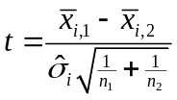

where the numerator is the difference in the means of log expression for gene i in the two classes, n₁ and n₂ are the number of samples in the two classes, and 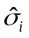 denotes the square root of the usual within class variance for gene i. The within class variance is computed by a weighted average of the variance of log expression in each of the two classes. With the usual t test, under the null hypothesis, the t value has a t distribution with n₁+n₂-2 degrees of freedom. For the randomized variance model, the same formula for t is used, except that is replaced in the denominator by 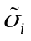 where

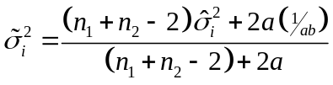

The quantity 1/ab is an estimate of the expected variance for the inverse gamma model. Consequently, 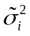 is a weighted average of the usual gene specific variance and the average variance for all the genes. The weight given to the gene specific variance is the total number of samples in the two classes minus two. The weight given to the average variance for all the genes is 2a. It can be shown rigorously that when the model assumption holds, that the t values computed using have a t distribution under the null hypothesis but the degrees of freedom is now n-2+2a. In cases where the number of samples n is small, this increase in degrees of freedom and the associated improvement in the estimation of variances results in improved statistical power for detecting differentially expressed genes. These results extend directly to the F distribution for comparing more than two classes.For details, see G Wright and R Simon, The randomized variance model for finding differentially expressed genes, Technical Reprort xx, Biometric Research Branch, National Cancer Institute, http://linus.nci.nih.gov/~brb ; P Baldi and AD Long, A Bayesian framework for the analysis of microarray expression data: regularized t-test and statistical inferences of gene changes, Bioinformatics 17:509-519, 2001.

Multivariate Permutation Tests for Controlling Number and Proportion of False Discoveries

Using a stringent p<0.001 threshold for identifying differentially expressed genes is a valid way for controlling the number of false discoveries. A false discovery is a gene which is declared differentially expressed among the classes, when in fact it is not. There are two problems with this approach to controlling the number of false discoveries. One is that it is based on p values computed from the parametric t/F tests or randomized variance t/F tests. These parametric p values may not be accurate in the extreme tails of the normal distribution for small numbers of samples. The second problem is that this approach does not take into account the correlation among the genes. Using stringent p value thresholds on the univariate permutation p values won’t be effective when there are few samples and will not account for correlations. We have implemented multivariate permutation tests that accomplish both objectives. They are described in detail in EL Korn, JF Troendle, LM McShane and R Simon, Controlling the number of false discoveries: Application to high dimensional genomic data; Technical Report 3, Biometric Research Branch, National Cancer Institute, 2002; http://linus.nci.nih.gov/~brb

The multivariate permutation tests are based on permutations of the labels of which arrays are in which classes. A large number of random permutations are considered. For each random permutation, the parametric tests are re-computed to determine a p value for each gene that is a measure of the extent it appears differentially expressed between the random classes determined by the random permutation. The genes are ordered by their p values computed for the random permutation (genes with smallest p values at the top of the list). For each potential p value threshold, the program records the number of genes in the list. This process is repeated for a large number of random permutations. Consequently, for any p value threshold, we can compute the distribution of the number of genes that would have p values smaller than that threshold for random permutations. That is the distribution of the number of false discoveries, since genes that are significant for random permutations are false discoveries. The algorithm selects a threshold p value so that the number of false discoveries is no greater than that specified by the user 95% of the time or 50% of the time. In a similar manner, we determine threshold p values so that the resulting gene list contains no more than a specified proportion of false discoveries (either 95% of the time or 50% of the time).

The class prediction tool produces a gene list ordered with the genes having the smallest parametric p values at the top. The length of the gene list is determined by the types of false discovery control selected. Generally we recommend using all of the options: univariate p value threshold (0.001); limiting number of false discoveries (10 default), and limiting proportion of false discoveries (0.10 default). The output tells you where to truncate the gene list in order to get each type of control.

The procedures for controlling the number or proportion of false discoveries are based on multivariate permutation tests. Although parametric p values are used in the procedures, s the permutation distribution of these p values is determined and hence the false discovery control is non-parametric and does not depend on normal distribution assumptions.

The multivariate permutation tests use the expression data much more efficiently than the univariate permutation tests. Consequently, we no longer recommend using the univariate permutation tests. We have retained the option to do the univariate permutation tests, but we have made the default to skip them. The multivariate permutation tests are particularly more effective when the number of samples is limited. In that case it may be impossible to obtain differences significant at the 0.001 level by a univariate permutation test, but quite possible to find significant genes while ensure that the number or proportion of false discoveries is controlled using the multivariate permutation tests.

The multivariate permutation tests take advantage of the correlation among the genes. For a given p value for truncating an ordered gene list; the expected number of false discoveries does not depend on the correlations among the genes, but the median number of false discoveries does. The distribution of number of false discoveries is skewed for highly correlated data. That is why we provide the length of the gene list associated with a specified median number of false discoveries or given proportion of false discoveries. You may think of those gene lists as being expected to contain the target number or proportion of false discoveries, although the median and expected number are not exactly the same. Requiring 95% confidence that the gene list does not contain more false discoveries than the target amount is a much more stringent condition and the associated gene lists will be much shorter than those based on the median. For many screening purposes, the lists based on a targeted median number or proportion of false discoveries will be adequate.

Two options presented for the Class Comparison Tool are important for some situations. If two classes are compared and the arrays are paired, then the paired t-test option should be selected. For example, if arrays have been prepared for the primary tumor and metastatic tumors of each patient, then the paired t-test option is appropriate and may improve the statistical power of the analysis.

If multiple arrays have been performed for some RNA samples, then the analysis must either be based on selection of a single array for each RNA sample or the averaging option should be used. The F-test is based on comparing the differences in mean log-ratios (or log-intensities) between classes relative to the variation expected in the mean differences. The variation is computed assuming that all the samples are independent. If there are multiple arrays for the sample RNA sample, then the within class variation will under-estimate the inter-class variation in means to be expected. The user should either omit technically inferior arrays, arbitrarily choose between technically satisfactory arrays that are tightly correlated (as determined using the Scatterplot tool), or utilize the averaging option. A combination of these approaches may also be used. If the averaging option is selected, the user must specify a column of the experiment design worksheet that provides RNA sample identifiers so that the tool can identify when there are multiple arrays for the same RNA sample. When analyzing paired sample, samples with replicated pairing id and classification labels will automatically be averaged.

The HTML output file created by the Class Comparison Tool gives the parametric p-value, the univariate permutation p-value (if requested), and the geometric mean ratio (geometric mean intensity for single color oligonucleotide arrays) in each class, and gene identifying information. The list is sorted by parametric significance level. If there are two classes, the list is in two parts; those genes down-regulated in class one relative to class two followed by those genes up-regulated in class one relative to class two. When there are more than two classes, the patterns of differential expression among the classes will be more varied for genes in the list. The Class Comparison Tool saves this gene list in the ..\ArrayTools\Genelists\User folder using the genelist name specified by the user. It is often useful to cluster the samples with regard to this gene list in order to better understand the pattern of genes across samples.

Class Prediction

The Class Prediction Tool is similar to the Class Comparison Tool in that it provides information about the genes that are differentially expressed among two pre-defined classes. The user specifies the classes by identifying a column of the experiment description worksheet. For the Class Prediction Tool, the column must only define two classes. Blanks labels in the column indicate that the corresponding array should be omitted from the analysis. Replicate arrays of the same RNA sample may be averaged, by entering a sample id column in the experiment design worksheet. When analyzing paired sample, samples with replicated pairing id and classification labels will automatically be averaged.

The user specifies a significance level to be used for determining the genes that will be included in the predictors; genes which are differentially expressed between the classes at a univariate parametric significance level less than the specified threshold are included in the predictor. It doesn’t matter whether the specified significance level is small enough to exclude enough false discoveries, because class prediction is not really about discovering differentially expressed genes. In some problems better prediction can be achieved by being more liberal about the gene set used as features. The predictors may be more biologically interpretable and clinically applicable, however, if fewer genes are included.

The Class Prediction Tool creates a multivariate predictor for determining which of the two classes a given sample belongs. Several multivariate classification methods are available. One of these is called the Compound Covariate Predictor. It is a weighted linear combination of log-ratios (or log intensities for single-channel arrays) for genes that are univariately significant at the specified level. By specifying a more stringent significance level, fewer genes are included in the multivariate predictor. Genes in which larger values of the log-ratio pre-dispose to class 2 rather than class 1 have weights of one sign, whereas genes in which larger values of the log-ratios pre-dispose to class 1 rather than class 2 have weights of the opposite sign. The univariate t-statistics for comparing the classes are used as the weights. Detailed information about the Compound Covariate Predictor is available in the Hedenfalk reference given above or in “A paradigm for class prediction using gene expression profiles” by MD Radmacher, LM McShane and R Simon, A paradigm for class prediction using gene expression profiles. Journal of Computational Biology 9:505-511, 2002., also available in Technical Report 01, 2001, Biometric Research Branch, National Cancer Institute, http://linus.nci.nih.gov/~brb/TechReport.htm).

In addition to the compound covariate predictor, several other prediction methods are available. Diagonal linear discriminant analysis is similar to the Compound Covariate Predictor, but not identical. It is a version of linear discriminant analysis that ignores correlations among the genes in order to avoid over-fitting the data. Many complex methods have too many parameters for the amount of data available. Consequently the appear to fit the training data used to estimate the parameters of the model, but they have poor prediction performance for independent data. The study by Dudoit et al. (S Dudoit, J Fridlyand, TP Speed; Comparison of discrimination methods for the classification of tumors using gene expression data, Journal of the American Statistical Association 97:77-87, 2002) found that diagonal linear discriminant analysis performed as well as much more complicated methods on a range of microarray data seta.

The Nearest Neighbor predictor is based on determining which expression profile in the training set is most similar to the expression profile of the specimen whose class is to be predicted. The expression profile is a vector of log-ratios or log-intensities for the genes selected for inclusion in the multivariate predictor. Euclidean distance is used as the distance metric for the Nearest Neighbor predictor. Once the nearest neighbor in the training set of the test specimen is determined, the class of that nearest neighbor is taken as the prediction of the class of the test specimen. k-Nearest Neighbor Prediction is similar. For example with the 3-Nearest Neighbor algorithm, the expression profile of the test specimen is compared to the expression profiles of all of the specimens in the training set and the 3 specimens in the training set most similar to the expression profile of the test specimen are determined. The distance metric is again Euclidean distance with regard to the genes that are univariately significantly differentially expressed between the two classes at the threshold significance level specified. Once the 3 nearest specimens are identified, their classes vote and the majority class among the 3 is the class predicted for the test specimen.

The Class Prediction Tool also offers Nearest Centroid Prediction. In the training set there are samples belonging to class 1 and to class 2. The centroid of each class is determined. The centroid of class 1, for example, is a vector containing the means of the log-ratios (or log intensities for single label data) of the training samples in class 1. There is a component of the centroid vector for each gene represented in the multivariate predictor; that is, for each gene that is univariately significantly differentially expressed between the two classes at the threshold significance level specified. The distance of the expression profile for the test sample to each of the two centroids is measured and the test sample is predicted to belong to the class corresponding to the nearest centroid.

The Class Prediction Tool also offers Support Vector Machine Prediction. A support vector machine (SVM) is a class prediction algorithm which has appeared effective in other contexts and is currently of great interest to the machine learning community. SVMs were developed by V. Vapnik (The Nature of Statistical Learning. Springer-Verlag, New York, 1995). We have implemented SVMs with linear kernel functions as our experience has been that more complex SVMs perform less well for this application. The SVM predictor is a linear function of the log-ratios or the log-intensities that best separates the data subject to penalty costs on the number of specimens misclassified. In the options dialog, the user can alter the default penalty cost or the cost of misclassifying a specimen of class 1 relative to misclassifying a specimen of class 2. We use the LIBSVM implementation of Chang and Lin.

For all of the class prediction methods requested, the Class Predictor Tool provides an estimate of how accurately the classes can be predicted by this multivariate class predictor. The cross-validated misclassification rate is computed and the results are reported. The cross-validation process omits one sample at a time. For each sample omitted, the entire analysis is repeated from scratch, including the determination of which genes are univariately significant on the reduced training sample. From that gene list, a multivariate predictor is constructed and applied to the sample that was omitted. The program records whether that prediction was correct or not. This is repeated, omitting all of the samples one at a time. The output table shows which samples were correctly and incorrectly predicted, and the overall cross-validated misclassification rate. The output table is arranged so that you can see the extent to which the different predictors agree or disagree for each specimen left out of the training set. Because of the large number of candidate predictor variables, it is essential to use cross-validation or some similar method to determine whether the model predicts accurately. Even with classes that do not differ in expression profiles, it is very easy to develop models that predict perfectly when measured in a non cross-validated manner. Such models would be useless for application with independent data.

In addition to providing the cross-validated misclassification information, the Class Prediction Tool also provides the permutation p value for the cross-validated misclassification error rate. That is, for each random permutation of class labels, the entire cross-validation procedure is repeated to determine the cross-validated misclassification rate obtained from developing a multivariate predictor with two random classes. The final p value is the proportion of the random permutations that gave as small a cross-validated misclassification rate as was obtained with the real class labels. There is a cross-validated misclassification rate and a corresponding p value for each class prediction method requested. The user inputs the number of permutations desired. At least 1000 permutations should be specified for a valid permutation p value on the cross-validated misclassification rate. The user may specify only 1 permutation and will quickly obtain the appropriate gene list and valid cross-validated misclassification rates. Only the p values associated with the cross-validated misclassification rates will be missing.

Note that the list of genes which are used to form the class predictors will coincide with the list of genes produced by the Class Comparison Tool for the same analysis between the two classes. The only exception is when there is only one nonmissing value in one of the two classes, or when the variance in one of the two classes is zero. In that case, the compound covariate predictor imputes the p-value for that gene to be 1, rendering that gene nonsignificant for that permutation or analysis, whereas the Class Comparison Tool does not.

The Class Prediction Tool saves this gene list in the ..\ArrayTools\Genelists\User folder using the genelist name specified by the user.

Prediction for new samples

The class prediction tool can be used to classify samples not used in the model building process. In the class prediction dialog, check the box labeled “Use separate test set” . You should create a column in your experiment descriptor worksheet that indicates which arrays contain samples that are to be included in the model building process (labeled “training”), which are to be used only for classification prediction once the model building is completely finished (labeled “predict”), and which samples are to be excluded entirely from both the training and test sets (labeled “exclude”). Predictions will be made for the samples labeled “predict” using all of the class prediction methods requested in the dialog.

Ususally, you do not have a separate set of samples that you wish to withhold from the model building process when the analysis is first done. The model building process itself uses leave-one-out cross validation, and so it is not necessary to have a separate test set. Sometimes, however, after the model is built, you have additional samples whose classes you wish to predict using the previously developed model(s). We have enabled you to do this by re-building the model using the initial set of samples, and to then predict for the new samples in a combined analysis. This has been more direct for us to implement, rather than trying to save the originally developed model, since in cases like k-nearest neighbor classifiers, the entire dataset is needed for classification of new samples.

Survival analysis

The survival analysis tool finds genes that are predictive of survival time for patients. Since some patients/animals may still be alive at the time of analysis, their survival times from entry on study is censored; that is, it is at least as long as survival measured to date, but longer by an unknown amount. There are many statistical methods for analysis of censored survival data. The most popular method is Cox’s proportional hazards model ( ). This is a regression model in which the hazard function for an individual is a function of predictor variables. In our case the predictor variables are log expression levels. The hazard function is the instantateous force of mortality at any time conditional on having survived till that time. The proportional hazards model postulates that the logarithm of the hazard of death is a linear function of the predictor variables, linked by unknown regression coefficients. For more details see biostatistics texts or the original paper (DR Cox, Regression models and life tables, J.Royal Stat Soc B 34:187-202).

The survival analysis tool fits proportional hazards models relating survival to each gene, one gene at a time and computes the p value for each gene for testing the hypothesis that survival time is independent of the expression level for that gene. Gene lists are created based on these p values in the same way as in the Class Comparison tool. The p values can be used to identify gene lists using multivariate permutation tests for controlling the number or proportion of false discoveries. Or the gene list can simply consist of the genes with p values less than a specified threshold (0.001 is default).

Specifying replicate arrays and paired samples

To enter paired samples into an analysis, the user must create a descriptor variable on the Experiment descriptors sheet in which a unique value is given for each pair. The following example shows the experiment design sheet for a paired analysis:

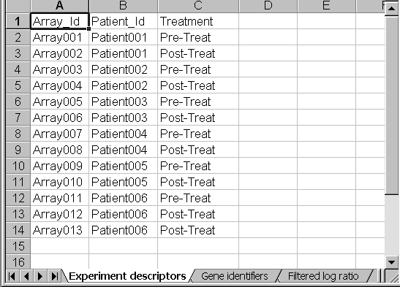
Here, the pre-treatment samples are to be compared against the post-treatment samples for each patient. The pairing variable is Patient_Id and the class variable to be compared is Treatment. Note that both Array012 and Array013 contain post-treatment samples for Patient006. In that case, the average of the two arrays will be used for the analysis.
When an unpaired analysis is used, the user should make sure to specify whenever there are replicate arrays which have been performed using the same sample. The following example shows an experiment descriptor sheet in which replicate arrays were performed for some of the samples:
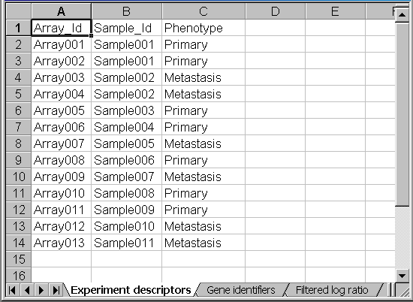

In this case, Sample_Id is the replicate variable to average over. Since Array001 and Array002 have the same Sample_Id, their average will be used for the analysis. Similarly, Array002 and Array003 will be averaged for the analysis. All the other arrays will be used as-is, since they have no replicates.

Programmable Plug-In Faciltiy

BRB-ArrayTools has a plug-in facility that enables users or methodology developers to extend the tool set built in to BRB-ArrayTools by providing their own tools. Users can then easily add-in the new tools to their version of BRB-ArrayTools and use them in the analysis of their data. The extensions must be written as functions in the R statistical programming language. R is an open source and very powerful statistical language that is popular with academic statistical scientists. It is in many ways a public domain version of S+, although each language has some features missing in the other. There is a growing body of R functions developed for the analysis of microarray data and the plug-in facility can give BRB-ArrayTools users and R software developers access to each other via BRB-ArrayTools.

Detailed information about the creation and use of add-in R functions is described in the BRB-ArrayTools Plug In Guide. Here we will give an overview of the plug-in facility. In considering R plug-ins there are two perspectives, one for the R tool developer and one for the BRB-ArrayTools user analyzing his/her data and wanting to utilize plug-ins.

For the plug-in user, the process of installing and accessing a plug-in is quite simple. The BRB-ArrayTools main menu contains a “Plug In” entry and a “Load Plug In” sub-menu entry. The Load Plug In dialog box askes for the path name of the plug in and it asks whether the user wants the plug-in added to the plug-in menu for future use. When the user clicks the “Load” button on the Load Plug In dialog box, the plug-in is launched and it will prompt the user for any further information it needs. BRB-ArrayTools will pass the R plug-in any data that it needs in the user’s Project Workbook that has already been collated by the user. The output of the analysis performed by the plug-in will be directed to a file and that file will be opened either by the plug-in itself or by the user. The user only needs to know the name of the plug-in. In using plug ins obtained from others, the user has to install the plug in in the PlugIns folder of the BRB-ArrayTools directory. There is a .r sub-folder for r functions, a .plug sub-folder for plug-in interfaces created by developers, and a .txt sub-folder for readme files created by developers.

The creation of R plug-ins for BRB-ArrayTools is also relatively easy. The first step is to write the R function that performs the desired analysis. This function will be launched by the BRB-ArrayTools user as described above, and BRB-ArrayTools will pass to the R function the information in the active collated workbook that the function needs. The data will be passed via the COM (Common Object Module) architecture and the developer need not read any files to obtain the desired data. In writting the R function, the developer can name the available data objects provided by BRB-ArrayTools any way he/she chooses. Because the R function runs in the background as a COM object, output from the function should be written to a file. The R function may open the file before terminating or the user can open the file.

The second step in creating a plug-in is to create the interface between the R function and BRB-ArrayTools. We provide a wizard to make this step easy. The wizard enables the developer to tell BRB-ArrayTools what data objects the R function needs and what names the R function wants associated with those data objects. The wizard also enables the developer to prompt the user for additional data input. The input dialog will be in the format of the Micrososft Windows type of dialog boxes used by BRB-ArrayTools but the VBA coding of these dialogs will be automatically generated by BRB-ArrayTools using information provided by the developer in his/her dialog with the wizard. For more information, see the BRB-ArrayTools Plug In Guide.

Hands-on practice using a sample dataset

In the BRB-ArrayTools installation folder, there is a sample dataset called BreastSamples which is actually a subset of a dataset published by Ross, et al.¹, and contains data from thirteen microarrays. Nine microarrays were performed on cell-line samples, and four microarrays were performed on tissue samples. The nine microarrays included three which were performed on the same cell-line sample (MCF7). Two cell-line samples which were derived from the same patient (MDA-MB-435 and MDA-N). The four tissue samples included a normal breast sample, as well as a lymph node sample collected from one of the breast cancer patients (BC2).

To begin using the sample dataset, unzip the BreastSamples.zip file, and open a few of the files in Excel to examine their contents. Then begin the hands-on tutorial by following the instructions for Example 3 under the "Collating the data" chapter of this manual. For the examples in this tutorial, we used the default filtering criteria, and also set the maximum number of missing values to 3.

Note
The analyses in this tutorial are chosen to illustrate the functionality of BRB-ArrayTools, and should not be considered a prescription for how the user's own data should be analyzed.

In this particular dataset, we might be interested in comparing cell-lines versus tissue samples, for example. One qualitative way to see if there is much difference between these two classes of samples is to use the scatterplot of phenotype averages. To run this analysis, click on Scatterplot → Averaged over phenotype classes, and select Cell-type as the phenotype class to average over.

The following plot will be produced on a Scatterplot worksheet in the collated project workbook. Clicking on Select All Outliers will highlight all the genes which have greater than a four-fold difference between the average log-ratio over the cell-line samples and the average log-ratio over the tissue samples, and list these genes in the panel beside the plot, with hyperlinks to clone reports.
Example of scatterplot of phenotype averages:
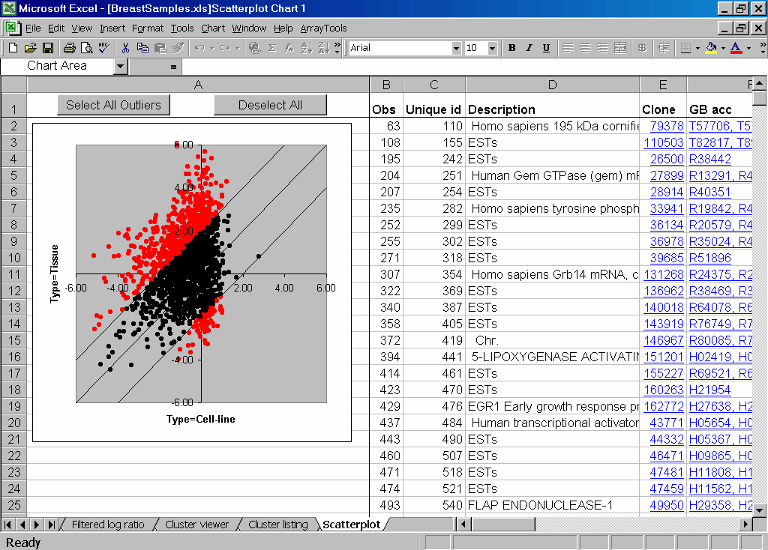

Since there seem to be lots of genes which are differentially expressed between cell-line and tissue samples, we might be interested in using the Class Comparison tool to find a geneset which discriminates between the two cell-types. To use the Class Comparison tool, we first have to add a column in the experiment descriptor sheet indicating that some of the arrays were "replicates". In the SampleId column, three arrays were given the same label, since they were all performed using the same cell-line MCF7. Another pair of arrays, MDA-MB-435 and MDA-N, were also given the same label, since they were performed using cell-lines which were derived from the same patient. One array, BC2_Lymph_Node, was not given a label since it is not a breast sample, and will be excluded from the analysis.
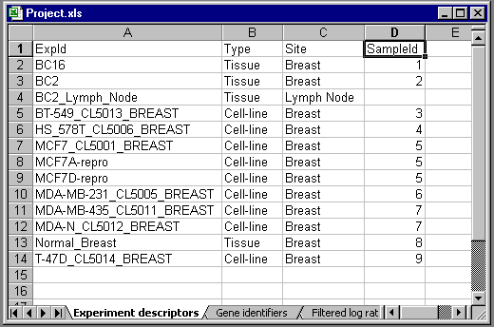

To run the analysis, click on Classification → Class Comparison, and select Type as the phenotype class variable. Select the checkbox for averaging replicate arrays over the SampleId descriptor variable. For this analysis, you should use all available genes, so you should click on the Filter button in the Class Comparison dialog box, and deselect the Log-ratio Variation Filter on the Gene Filters page. Now click OK for this analysis. You will see a DOS window minimized at the bottom of your screen, where a script is running to compute the class comparison output. The script will take a few minutes to run. When the script is finished running, an HTML page will open up similar to the following output:
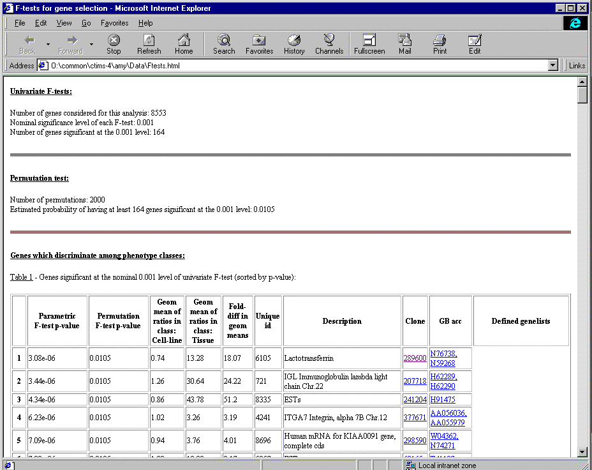

There were 164 genes identified as significantly different between the two classes with an F-test p-value of 0.001. In 2000 random permutations of the class labels, the chance of finding 164 or more significant genes was only 0.0105. This is the p-value for the global test of whether or not the two classes differ with regard to the expression profile. In the table, the F-test p-value and the permutation p-value are given for each gene for which the F-test p-value was less than 0.001.

The genelist in the HTML table is automatically saved using the genelist name specified by the user.
Now if we run a cluster analysis of samples using only this set of 164 genes, we will see that the samples form two very tight tissue and cell-line clusters which are highly reproducible. Here we did not center the genes, and we used an uncentered correlation with average linkage. We selected the arrays using the SampleId descriptor variable, so that the BC2_Lymph_Node sample was not included in the analysis. The average correlation with each cluster is fairly tight (around 0.8).
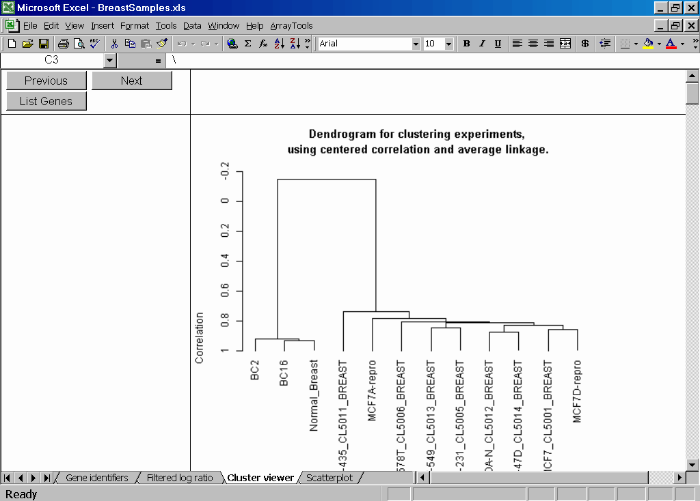
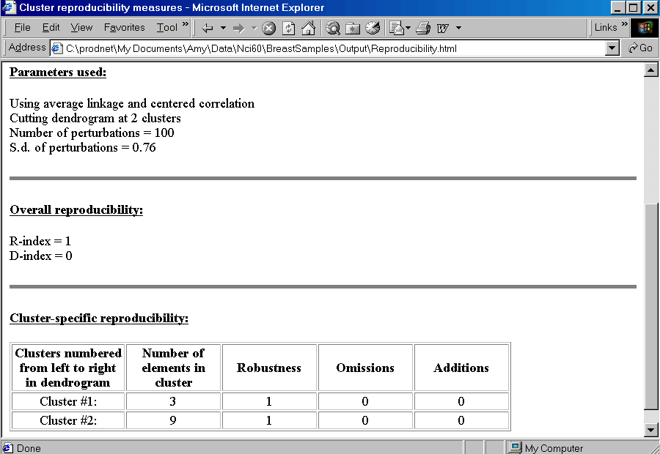

If we had run a cluster analysis of samples using the entire geneset, we would not have seen two clear clusters, due to the heterogeneity in the cell-lines. The genes which are not differentially expressed between the two cell types would have dominated the distance computation so that the effect of the differences between the two cell types would have been masked.
We can run the multidimensional scaling tool to visualize the relationships between these samples, based on the 164 genes which were significant from the Class Comparison tool.
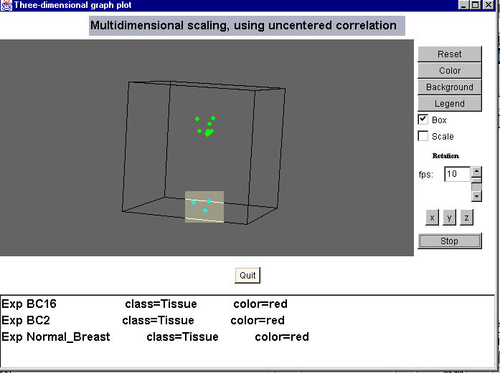
The three-dimensional scatterplot may be rotated by clicking on the x, y and z buttons, and individual points may be identified by brushing over the points.

Because the global test of clustering can only be run on datasets with at least 30 samples, the global test of clustering was not run on this particular dataset.

If we run a hierarchical clustering of the genes, we see from the dendrogram that there are two clear gene clusters with fairly tight average correlations (around 0.7).
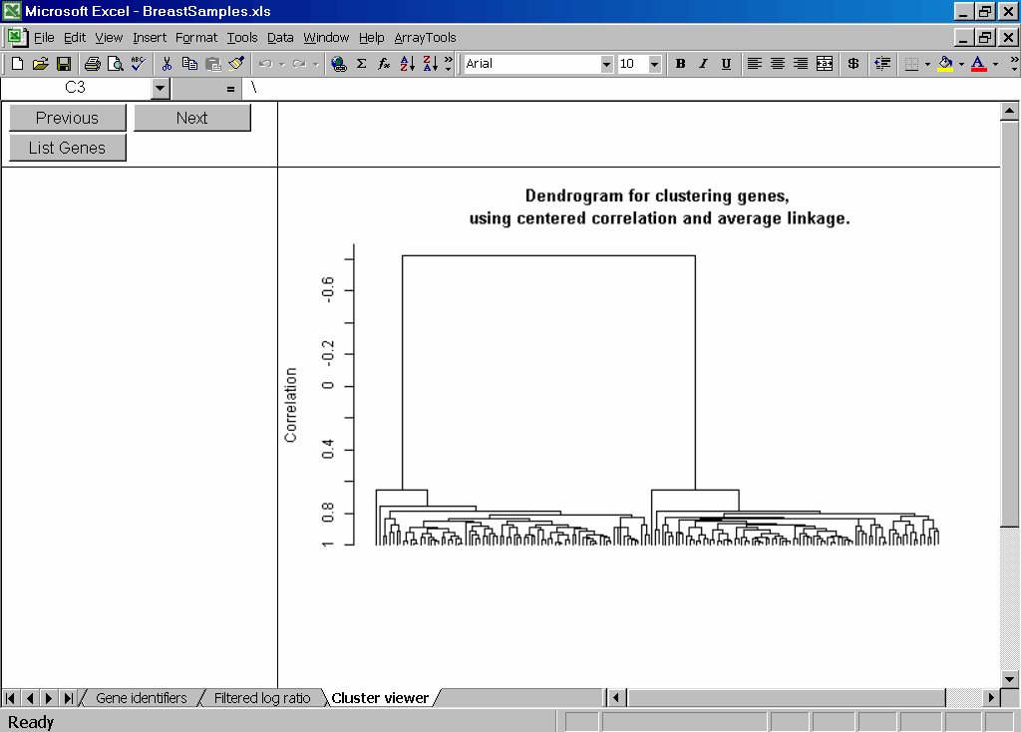

The color image plot gives a graphical depiction of two gene clusters:
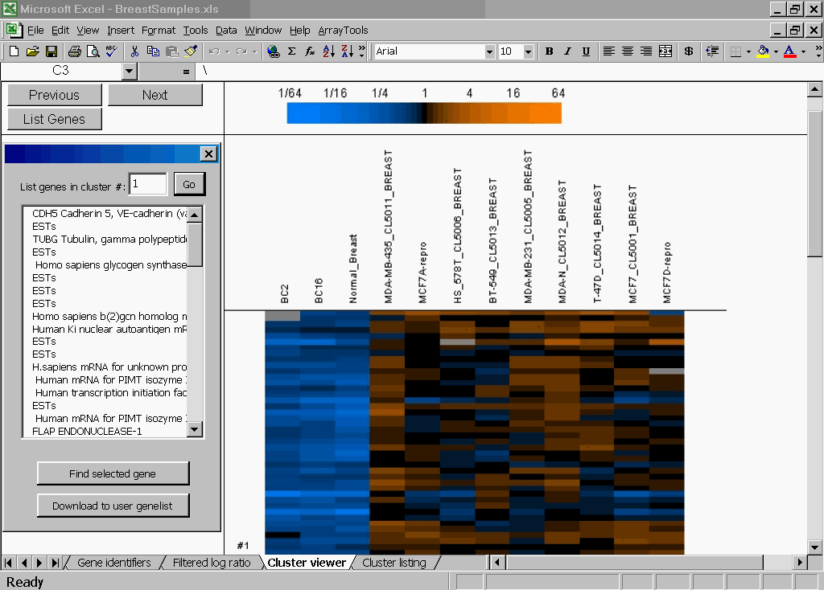

If we scroll down the image plot, we would see that Cluster #1 is mostly underexpressed in the tissue samples, while Cluster #2 is mostly overexpressed in the tissue samples. The differences between the two clusters is not as dramatic in the cell-line samples.

The image plot of cluster medians illustrates this even more clearly:
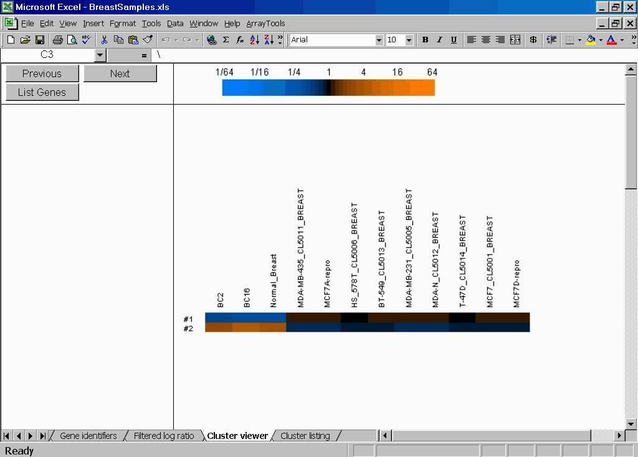

A “profile” lineplot is also produced for each cluster:
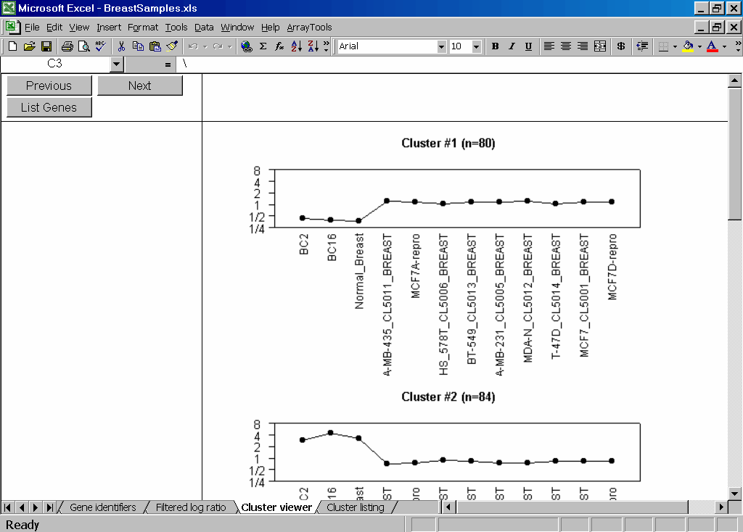

Further help

Some useful tips

Excluding arrays from an analysis

Some of the analyses within BRB-ArrayTools can be run on a subset of the arrays in the collated project workbook. For the hierarchical clustering and multidimensional scaling tools, an array will be excluded from the analysis if it has a blank label within the designated experiment descriptor variable. For the scatterplot of phenotype averages and the classification tools, an array will be excluded from the analysis if it has a blank label within the selected phenotype class variable.

Extracting genelists from HTML output

Sometimes the user may need to extract columns of data from the HTML tables which are produced by BRB-ArrayTools. For example, the user might wish to include the HTML genelist table produced by the classification tools in a Word document for publication. Or the user might need to extract the t-values and midpoint values from the compound covariate predictor output for use in classifying new samples. Or the user might wish to sort the genelist table by a particular column.

HTML tables can be easily converted to tables in Word or columns in Excel. You can do this in one of two ways. One way is to select the HTML table by left-clicking and dragging the mouse over the entire table, and then copying to the buffer through Edit → Copy (or Ctrl-V). Then open up a blank Word or Excel document, and paste the contents of the buffer into the document through Edit → Paste (or Ctrl-C).

Another way is to open the HTML file within Word or Excel using the File → Open menu. In the Open dialog box, go to the Files of type field and select HTML Document (in Word or Excel 97) or select either All Microsoft Excel Files or Web Pages (in Excel 2000). Now browse for the HTML document which you would like to convert. Once the table has been converted to a Word table or to cells within Excel, it is very easy to add to, delete, or edit any of the rows or columns in the table. Note that all hyperlinks are preserved when converting HTML tables to Word or Excel.

Creating user-defined genelists

The best utility to use for creating user-defined genelists is Notepad. This is because Notepad always saves files as ASCII text files, without adding the hidden formats into the file which some word processors do. To open Notepad, click on Windows Start Button → Programs → Accessories → Notepad.

To save any list of genes from a column of cells within Excel, simply select the cells by left-clicking and dragging your cursor over the cells, and copying to the buffer through Edit → Copy (or Ctrl-V). Then open up a blank text file in Notepad, and paste the contents of the buffer into the text file through Edit → Paste (or Ctrl-C). It is possible to save the list of selected genes from a BRB-ArrayTools scatterplot in this way.

To save any list of genes from an HTML table, first convert to Word or Excel, then copy the desired column of gene identifiers into a Notepad document. Of course, the genelists from the Class Comparison or the Compound Covariate Predictor tool are already automatically saved into the ..\ArrayTools\Genelists\User folder. However, the user may be interested in saving the genes from an HTML table for purposes other than to enable subset analyses within BRB-ArrayTools, since the HTML tables report the genes in sorted order by p-value or another criterion.

Re-playing the three-dimensional rotating scatterplot

Currently there is no tool for saving the rotating three-dimensional scatterplot of the multidimensional scaling coordinates as a movie. Future releases of BRB-ArrayTools may include a tool to create the rotating scatterplot as an object within a PowerPoint presentation. However, the current release only allows the user to save a screenshot of the scatterplot or re-play the scatterplot from a DOS command.

To save a still-shot of the screen, simply press the PrintScreen button on the keyboard, then go into any application which has image editing capabilities, and paste the screenshot (usually by pressing the Ctrl-V key combination).

To re-play the rotating three-dimensional scatterplot from a DOS command, follow these instructions. (Note that the following steps can also be used to show the three-dimensional rotating scatterplot with larger point sizes.)

- Open an MS-DOS window (this can usually be found by going to the Windows Start Button).

- Find the folder which contains the java.exe file (usually this will be in the C:\Program Files\JavaSoft\Jre\1.2\bin folder). Use the cd command in the MS-DOS window to change to that directory. If the folder is in a different drive, then you may first need to change to that drive by typing either c:\ or d:\ at the command prompt.

- Set the CLASSPATH parameter (in capital letters) to the java sub-folder of the ArrayTools installation folder.

- Invoke the ThreeDimensionalGraph java application by typing a java command at the prompt, with the following required parameters. (The keyword ThreeDimensionalGraph is case-sensitive.)

java ThreeDimensionalGraph <mds file> <class file> <background> <title> <width> <height> <shape>

The command line parameters are as follows:

mds file = the file which contains the multidimensional scaling coordinates along with other data. The full path of the mds file should be given in quotes. This file is usually found as mds.dat in the ArrayTools installation folder.

class file = the file which contains the class names and associated plotting colors. The full path of the class file should be given in quotes. This file is usually found as cls.dat in the ArrayTools installation folder.

background = the color to use for the background of the rotating scatterplot. The allowable values for this parameter are: default (gray), and the 13 standard Java color names.

title = a string enclosed in quotes, which will be used as the title for the rotating scatterplot.

width = an integer representing the width of the plotted points.

height = an integer representing the height of the plotted points.

shape = the shape of the plotted points. The allowable values for this parameter are: oval (becomes a circle when height=width), rectangle (becomes a square when height=width), diamond, triangle, and star.

If you find that the DOS command window does not allow you to type in such a long command, then you can move the mds.dat and cls.dat files to the root folder in order to shorten their pathnames within the DOS command.

The following figure shows an example of a DOS session which was used to re-play the multidimensional scaling plot:
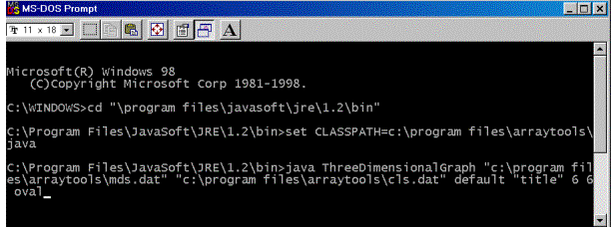

Stopping a computation after it has started running

Sometimes a user may want to cancel a computation after it has started running. If the computation is running in Excel, then the user may stop the computation from within Excel by pressing the ESC key, or by pressing the Ctrl-Break key combination.

However, if the computation is running within the R Server, it is not possible to cancel the computation from within Excel, but the computation may be stopped through the Windows manager. To stop a computation which is running within the R Server, you must go to the Windows Task Manager or Close Program window (by pressing the Ctrl-Alt-Del key combination), and kill the StatConnectorSrv process. In Windows NT, this is usually listed as STATCO~1.EXE under the Processes window of the Task Manager, whereas in Windows 98 this is listed as Statconnectorsrv in the Close Program window. Once the StatConnectorSrv has been terminated, Excel will issue a series of messages notifying the user that an error has occurred. You may ignore these error messages, since the error was induced by the termination of the StatConnectorSrv process. If the error message asks if you want to debug, click No. After the R COM has been closed, you should click on ArrayTools → Utilities → Refresh R Session to start a fresh R session.

If the computation is running as a batch job within an MS-DOS window, then the computation may be cancelled by simply closing the MS-DOS window.

Determining the order of the arrays in the collated data

The Filtered log ratio (or Filtered log intensity) worksheet of the collated project workbook (as well as the other data variables in the project folder) contains a column of data corresponding to each array in the collated dataset. The order in which the arrays appear in the collated data is determined by the input format of the raw expression data files, not by the order in which the arrays appear in the experiment descriptor file.

For the horizontally stacked and vertically stacked input data formats, the order of the arrays in the collated data will be determined by the order in which the array data blocks appear within the original expression data file.

For the arrays in separate files input data format, the order of the arrays in the collated data is determined by the alphanumeric sorting order of the expression data filenames. Thus, if the expression data filenames are numbered, then leading zeroes may be needed in order to preserve their correct order. For instance, if the user has

Exp1.xls, Exp2.xls, Exp3.xls, … , Exp10.xls

as the expression data filenames, then the arrays should be renamed as

Exp01.xls, Exp02.xls, Exp03.xls, … , Exp10.xls

if the user wishes to preserve their order within the collated data. For single-channel data, the order of the arrays in the collated data may be important if the user wishes to specify which array to normalize all the other arrays against (since all the arrays are normalized to the first array in the dataset). To specify an array as the first array, simply rename its expression data file before collating so that it begins with an underscore. (An underscore precedes any numeral, and numerals precede alphabetic letters in an alphanumeric sorting order.)

Always save the collated project workbook when prompted!

Usually, BRB-ArrayTools will automatically save the collated project workbook as you close the workbook. If, however, you are prompted to save the collated project workbook when closing the workbook, then you should always choose Yes, even if you have just saved it. Choosing No may sometimes cause instabilities when you try to open the collated project workbook later during another session.

Troubleshooting the installation

Testing the R COM

If you experience difficulty with the RServer while using BRB-ArrayTools, you may wish to test the R COM to see if it was registered properly. The R1_2_0.exe installer should automatically register the R COM after unpacking all the files. However, there are glitches which may occur on some user's machines while registering the DLL. To test the R COM, double-click on the ..\Dcom\bin\vbtest.exe file in your R installation directory. When the StatConnector Test screen comes up, click on Start. If the R COM was registered properly, then a script will start to execute and a graphics window will appear with a plot of a line.

If the R COM was not properly registered, then you must manually register the R COM. To manually register the R COM:

- Click on the Windows Start Button and use the Find function to search for the location of the regsvr32.exe file. (Usually it will either be in the system or system32 folder of your Windows or Winnt folder.)

- Now open a MS-DOS window (usually by clicking on Windows Start Button → Program → Command Prompt ). Within the MS-DOS window, use the cd command to switch to the folder containing the regsvr32.exe file. Use the dir command to double-check that you have the folder containing that file.

i.e., type something like the following sequence of commands:
d:
cd d:\winnt\system32
dir regsvr32.dll

- Now type something like the following command:

regsvr32 "d:\program files\r\rw1020\bin\StatConnectorClnt.dll"

You should substitute the location of your own R installation folder for "d:\program files". You may or may not need the quotation marks, but you can try it both ways. You will know that the command has succeeded when you get a window popping up with a message like:

"DllRegisterServer in d:\program files\r\rw1020\bin\StatConnectorClnt.dll succeeded."

4) Once the regsvr32 command has succeeded, go back and test the R COM again by double-clicking on the ..\Dcom\bin\vbtest.exe file in your R installation folder.

Updating the R Server and BRB-ArrayTools library references

Usually the locations of library references needed by an add-in are automatically updated when the add-in is loaded. Sometimes when loading the ArrayTools.xla add-in, however, a Visual Basic message may appear with a message such as "Project not found", indicating that the appropriate library references have not been properly updated. In that case, the user will need to manually update the library references within the add-ins. However, before updating the library references, first follow the instructions above to test and make sure that the R COM is running properly.

To manually update the library references in the RServer:

- Open the Visual Basic Editor (VBE) by clicking on Tools → Macro → Visual Basic Editor from the Excel menubar. (If you had clicked on Debug when you got the error message, then the VBE is probably already open, with the offending command highlighted. In that case, click on Run → Reset from the VBE menubar.)

- Within the VBE, open the Project Explorer if it is not already open, by clicking on View → Project Explorer from the VBE menubar.

- Scroll through the tree pictured in the Project Explorer and click on RServerVBAlib (RServer.xla).

- Then click on Tools → References from the VBE menubar. You will see a list of available library references, with a checkmark besides all the references which are used by the RServer. The problem is likely to be that you don't have the following two libraries checked, or that the location reference for those libraries is pointing to a nonexistent file. Browse for the following two files from your R installation folder:

- ..\R\rw1020\bin\StatConnectorClnt.dll
- ..\R\rw1020\bin\StatConnectorSrv.exe

Once you have browsed for these two files, they should show up within the list of available references as:

- StatConnectorClnt 1.0 Type Library
- StatConnectorSrv 0.91 Type Library

- Now click on File → Save RServer.xla from the VBE menubar.

Now close down and restart Excel, and try loading the RServer.xla and ArrayTools.xla add-ins again. The problem will probably have been resolved.

If the problem persists, then try manually updating the library references in BRB-ArrayTools:

- Follow steps 1)-4) above, except browse for the file ..\ArrayTools\Excel\RServer.xla from the BRB-ArrayTools installation folder instead. This should show up within the list of available references as RServerVBAlib.

- There should also be a reference to something like Microsoft Visual Basic for Applications Extensibility in the list of available references. If it is not present or not checked, then ask your system administrator where the library exists, since the location of that library would be dependent upon your individual Excel installation.

- Now click on File → Save ArrayTools.xla from the VBE menubar.

- Close down and restart Excel, and try loading the RServer.xla and ArrayTools.xla add-ins again.

Reporting bugs

Bug reports should be e-mailed to Amy Lam at: alam@emmes.com. To make comments or request help, please post a message on the message board at the BRB-ArrayTools website:

http://linus.nci.nih.gov/BRB-ArrayTools.html

Due to limited resources, we cannot guarantee that we will be able to diagnose and fix all bugs reported by users. However we do try our best to respond to users within a reasonable time, and to advise the user or fix the problem whenever we can.

References

Published references:

Hedenfalk, I., Duggan, D., Chen, Y., Radmacher, M., Bittner, M., Simon, R., Meltzer, P., Gusterson, B., Esteller, M., Raffeld, M., et al., "Gene expression profiles of hereditary breast cancer", New England Journal of Medicine 344:539-548, 2001.

Ross, D., Scherf, U., Eisen, M., Perou, C., Rees, C., Spellman, P., Iyer, V., Jeffrey, S., Van de Rijh, M., Waltham, M., Pergamenschikov, A., Lee, J., Lashkari, D., Shalon, D., Myers, T., Weinstein, J., Botstein, D., Brown, P., "Systematic variation in gene expression patterns in human cancer cell lines", Nature Genetics 24:227-235, 2000.

Technical reports:

In addition, the following two references may be found as technical reports from the BRB website: http://linus.nci.nih.gov/~brb/TechReport.htm

Technical Report 001:A paradigm for class prediction using gene expression profiles. by Michael D. Radmacher, Lisa M. Mcshane, and Richard Simon

Technical Report 002:Methods for assessing reproducibility of clustering patterns observed in analyses of microarray data. by Lisa M. McShane, Michael D. Radmacher, Boris Freidlin, Ren Yu, Ming-Chung Li, and Richard Simon

